Bob Preuss and Amy Oslund, Pastors 1945 Prosperity Road

Leah Bergman, Director of Music Maplewood, MN 55109

Dan Woolley, Organist 651-777-1329

www.crosslutheranmaplewood.org [cross@pro-ns.net](mailto:cross@pro-ns.net)

***Cross Lutheran Church***

**THE EIGHTEENTH SUNDAY AFTER PENTECOST**

**October 12, 2014**

**ALTERNATIVE SERVICE**

**Our Mission Statement**

**Cross Lutheran Church is a community of believers united by our baptism into Christ Jesus. We are committed to proclaiming and teaching the Good News of God’s love and sharing His love by serving our neighbors in all we do. We invite all to be a part of our fellowship as we grow in grace and follow Christ.**

***Bold Print*** *– indicates congregation responds as a whole*

***\**** *– indicates congregation should stand as able*

**GATHERING SONGS**

**ANNOUNCEMENTS**

**\*CONFESSION AND FORGIVENESS** *You Are Mine*p. 1

**\*OPENING HYMN** *Shall We Gather at the River* RB # 77

**CALL TO WORSHIP** *O God in Heaven*p. 2

**\*GOD’S CALL TO US** *Go, Make Disciples* p. 3

**\*PRAYER OF THE DAY**

**Lord of the feast, you have prepared a table before all peoples and poured out your life with abundance. Call us again to your banquet. Strengthen us by what is honorable, just, and pure, and transform us into a people of righteousness and peace, through Jesus Christ, our Savior and Lord. Amen.**

**FIRST LESSON** Isaiah 25:1-9 O.T. p. 652

**PSALM 23**

*Cantor sings refrain (****R****). The congregation then repeats the refrain.*

*Congregation responds with the* ***bold verses.***

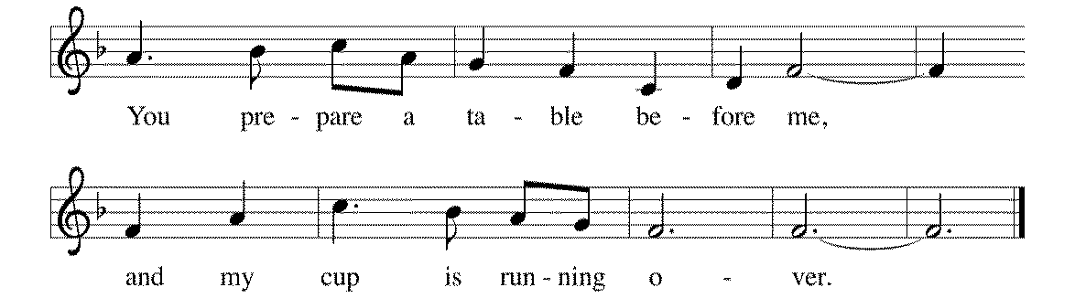



The LORD | is my shepherd;

I shall not | be in want.

2**The LORD makes me lie down | in green pastures**

**and leads me be- | side still waters.**

3You restore my | soul, O LORD,

and guide me along right pathways | for your name's sake.

4**Though I walk through the valley of the shadow of death, I shall | fear no evil;**

**for you are with me; your rod and your staff, they | comfort me. R**

5You prepare a table before me in the presence | of my enemies;

you anoint my head with oil, and my cup is | running over.

6**Surely goodness and mercy shall follow me all the days | of my life,**

**and I will dwell in the house of the | LORD forever. R**

**SECOND LESSON** Philippians 4:1-9 N.T. p. 198

**\*GOSPEL ACCLAMATION** *The God of Heaven Thunders* p. 3

*The entire assembly will read the Gospel together; pew Bibles can be found in front of you.*

**\*GOSPEL** Matthew 22:1-14 N.T. p. 24

**THE SERMON**

**\*HYMN OF THE DAY** *There’s a Wideness in God’s Mercy*RB # 54

**\*APOSTLES’ CREED** *I Believe in God the Father*p. 4

**\*PRAYERS OF THE PEOPLE WITH SUNG RESPONSE** p. 5

**\*SHARING THE PEACE OF THE LORD**

**OFFERING** *One Lord, One Faith* Marcelyn Smale

**\*OFFERTORY RESPONSE** *Give Thanks with a Grateful Heart* p. 5

**\*WORDS OF INSTITUTION** p. 6

**\*THE LORD’S PRAYER**

**DISTRIBUTION**

**To make the distribution of the Lord’s Supper as easy as possible, we ask that people who wish to commune and who use a wheelchair or walker come to the front first to receive the Sacrament.**

**ANNOINTING**

**Prayer for healing and anointing with oil is offered in the narthex during Holy Communion. Any worshipper wishing to receive these gifts may proceed there after receiving the host and the cup, and before returning to the pew.**

**LAMB OF GOD** *Now Behold the Lamb of God* p. 6

*We Come to the Hungry Feast* RB # 17

*The Journey of Praise* RB # 16

*What Can Wash Away My Sin?* RB # 80

*Jesus Loves Me!* RB # 82

**\*POST COMMUNION PRAYER** p. 6

**\*BENEDICTION** p. 6

**\*CLOSING HYMN***We Are Called*RB # 65

\***DISMISSAL** p. 7

**\*POSTLUDE** *You Are Mine* p. 7

The Fifth Commandment is: **You shall not kill.** What does this mean? We are to fear and love God so that we do not hurt our neighbor in any way, but help them in all their physical needs.

To Our Guests and Visitors Today: Every baptized believer who is of age is invited to receive the Lord’s Supper as we worship. The invitation is extended to each of us by the Lord himself, because he is the host of the meal. We also believe that he is the meal; that is that “in, with, and under” the bread and wine we do receive the body and blood of Christ, given and shed for us for the forgiveness of sins. Please follow the directions of the ushers if you wish to commune. Children under the age of ten are invited to receive a Word of blessing. ***Worshipers unable to commune at the front of the church****…Please register with an usher and a lay minister will bring the Supper to you in your pew*.

###### **THIS WEEK AT CROSS**

Sunday, October 12 9:00am Worship Service

10:30am Sunday School, Teen/High School, Adult Classes 3:30pm – 8:30pm Roca de Horeb

7:00pm – 9:00pm 7th Day Adventist

Monday, October 13 7:00pm Board of Education Meeting

7:00pm – 9:00pm 7th Day Adventist

Tuesday, October 14 9:30am – 11:00am Isaiah Bible Study

6:30pm – 8:00pm Isaiah Bible Study

7:00pm – 9:00pm 7th Day Adventist

7:30pm Roca de Horeb

Wednesday, October 15 NO CONFIRMATION CLASS

7:00pm Choir Rehearsal

***CROSS CURRENTS ARTICLES DUE***

Thursday, October 16 6:30pm Worship Service at The Shores of Lake Phalen

7:00pm – 9:00pm 7th Day Adventist

Friday, October 17 6:00pm – 10:00pm Roca de Horeb

7:00pm – 9:00pm 7th Day Adventist

Saturday, October 18 6:00am – 8:00am Roca de Horeb

8:00am Take A Chance Catering Breakfast

9:00am Fall Work Day

9:30am –12:30pm 7th Day Adventist

5:30pm –8:30pm Roca de Horeb

Sunday, October 19 9:00am Worship Service

10:30am Sunday School, Teen/High School, Adult Classes

3:30pm – 8:30pm Roca de Horeb

**Today you will find in the bulletin a table prayer**. We know that our Lord is the source of all blessings, and that it is most fitting for us to give thanks before we eat. Some people always pray the same prayer. Others prefer to pray different prayers – some don’t pray at all. A different prayer will be included each month to help us all in this daily devotion.

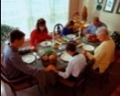Table Prayer

Lord God, heavenly Father, bless us and these your gifts, which we receive from your bountiful goodness, through Jesus Christ our Lord. Amen.

Description: MCj03075560000[1]*Description: j0199727 Stewardship Verse*

*John 15:16-17*

*“You did not choose me but I chose you. And I appointed you to go and bear fruit, fruit that will last, so that the Father will give you whatever you ask him in my name. I am giving you these commands so that you may love one another.”*

Be a good steward of the earth; if you aren’t taking your bulletin home,   
please drop it in the recycling bin in the narthex. Thank you!