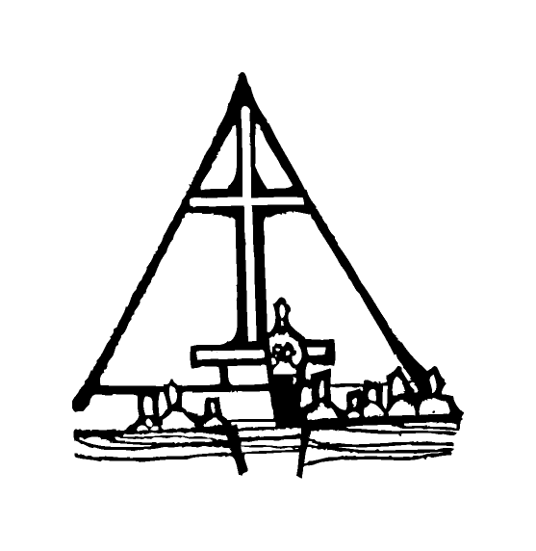Bob Preuss and Amy Oslund, Pastors 1945 Prosperity Road

Leah Bergman, Director of Music Maplewood, MN 55109

Dan Woolley, Organist 651-777-1329

[www.crosslutheranchurch.org](http://www.crosslutheranchurch.org) [cross@pro-ns.net](mailto:cross@pro-ns.net)

***Cross Lutheran Church***

**TWENTY THIRD SUNDAY AFTER PENTECOST**

**November 16, 2014**

**Evangelical Lutheran Worship Book – Holy Communion Setting Three**

We encourage worshippers to use the time in the sanctuary before the liturgy begins for silent meditation and prayer. The entire assembly will read the Gospel together; pew Bibles can be found in front of you, children’s Bibles and large print lessons are available from the ushers. Prayer for healing and anointing with oil is offered in the narthex during Holy Communion. Any worshipper wishing to receive these gifts may proceed there after receiving the host and the cup, and before returning to the pew.

***Bold Print*** *– indicates congregation responds as a whole*

***\**** *– indicates congregation should stand as able*

**PRELUDE** *Sonata*Mendelssohn

**ANNOUNCEMENTS**

**\*CONFESSION AND FORGIVENESS**  p. 94 (red tab)

**\*OPENING HYMN** *Come, Ye Thankful People, Come* ELW # 693

**\*GREETING** p. 138

**\*KYRIE** p. 138

**\*HYMN OF PRAISE** *This is the Feast* p. 140

**\*PRAYER OF THE DAY**

**Righteous God, our merciful master, you own the earth and all its peoples, and you give us all that we have. Inspire us to serve you with justice and wisdom, and prepare us for the joy of the day of your coming, through Jesus Christ, our Savior and Lord. Amen.**

**FIRST LESSON** Zephaniah 1:7, 12-18 O.T. p. 874

**PSALM –** Psalm 90:1-8, 12

*Cantor sings refrain (****R****). The congregation then repeats the refrain.*

*Congregation responds with the* ***bold verses.***

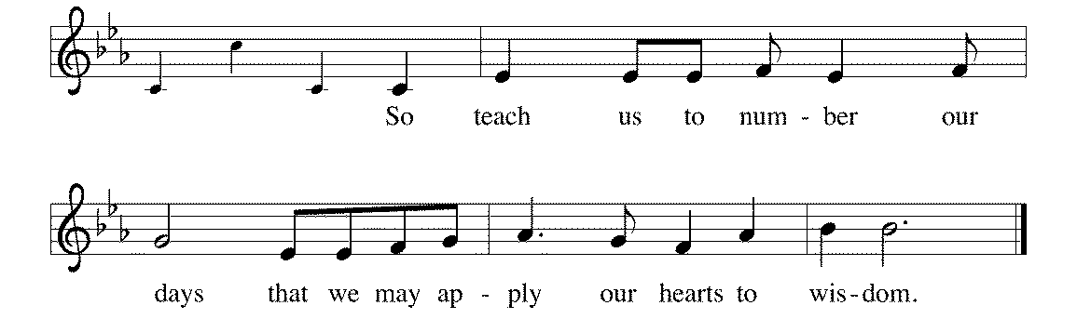



Lord, you have | been our refuge

from one generation | to another.

2**Before the mountains were brought forth, or the land and the | earth were born,**

**from age to age | you are God.**

3You turn us back to the | dust and say,

"Turn back, O child- | ren of earth."

4**For a thousand years in your sight are like yesterday when | it is past**

**and like a watch | in the night; R**

5you sweep them away | like a dream,

they fade away suddenly | like the grass:

6**in the morning it is | green and flourishes;**

**in the evening it is dried | up and withered.**

7For we are consumed | by your anger;

we are afraid because | of your wrath.

8**Our iniquities you have | set before you,**

**and our secret sins in the light | of your countenance.**

12So teach us to num- | ber our days

that we may apply our | hearts to wisdom. **R**

**SECOND LESSON** I Thessalonians 5:1-11 N.T. p. 205

**\*GOSPEL ACCLAMATION** *Alleluia*p. 142

*(P) The Holy Gospel according to Matthew 25:14-30 N.T. p. 28

**\*(C) Glory to you, O Lord.**

*(P) The Gospel of our Lord.

**\*(C) Praise to you, O Christ.**

**THE SERMON**

**\*HYMN OF THE DAY** *Now Thank We All Our God* ELW # 840

*As the congregation sings, worshippers who have brought their statements of intent are asked to proceed to the chancel and place them there. These statements reflect our commitment and part in the work of God’s kingdom. Those unable to do so, or who choose not to, may place their card in the offering plate or hand it to an usher after the service.*

**\*APOSTLES’ CREED** p. 127 (blue tab)

**\*PRAYERS OF THE PEOPLE**

**\*SHARING THE PEACE OF THE LORD**

**OFFERING** *The Gift of Love* Hal H. Hopson

**\*OFFERTORY RESPONSE** *Let the Vineyards* ELW # 184

**\*OFFERING PRAYER**

**Blessed are you, O God, maker of all things. Through your goodness you have blessed us with these gifts: our selves, our time, and our possessions. Use us, and what we have gathered, in feeding the world with your love, through the one who gave himself for us, Jesus Christ, our Savior and Lord. Amen.**

**\*WORDS OF INSTITUTION**

**\*THE LORD’S PRAYER** p. 145

**DISTRIBUTION**

**To make the distribution of the Lord’s Supper as easy as possible, we ask that people who wish to commune and who use a wheelchair or walker come to the front first to receive the Sacrament.**

**LAMB OF GOD** p. 146

*O Bread of Life from Heaven* ELW # 480

We Are All One in Mission ELW # 576

*Love Divine, All Loves Excelling* ELW # 631

*Come, Thou Fount of Every Blessing* ELW # 807

**\*POST COMMUNION PRAYER**

**\*BENEDICTION** p. 146

**\*CLOSING HYMN** *On What Has Now Been Sown* ELW # 550

**\*DISMISSAL** p. 146

**POSTLUDE** *Prelude in F Minor*

The Eighth Commandment is: **You shall not bear false witness against your neighbor.** What does this mean? We are to fear and love God so that we do not betray, slander, or lie about our neighbor, but defend them, speak well of them, and explain their actions in the kindest way.

To Our Guests and Visitors Today: Every baptized believer who is of age is invited to receive the Lord’s Supper as we worship. The invitation is extended to each of us by the Lord himself, because he is the host of the meal. We also believe that he is the meal; that is that “in, with, and under” the bread and wine we do receive the body and blood of Christ, given and shed for us for the forgiveness of sins. Please follow the directions of the ushers if you wish to commune. Children under the age of ten are invited to receive a Word of blessing. ***Worshipers unable to commune at the front of the church…Please register with an usher*** *and a lay minister will bring the Supper to you in your pew*.

###### **THIS WEEK AT CROSS**

**Today**, November 16 9:00am Worship Service

10:30am Sunday School Classes

10:45am Worship Service at The Homestead

3:30pm – 7:00pm Roca de Horeb

Monday, November 17 6:30pm 4th Grade The Creed Milestone Class

7:00pm Board of Education Meeting

Tuesday, November 18 7:30pm Roca de Horeb

Wednesday, November 19 7:00pm Choir Rehearsal

Thursday, November 20 6:30pm Worship Service at The Shores of Lake Phalen

Friday, November 21 6:00pm – 10:00pm Roca de Horeb

Saturday, November 22 6:00pm Roca de Horeb

9:30am –12:30pm 7th Day Adventist

5:30pm –8:30pm Roca de Horeb

Sunday, November 23 9:00am Worship Service – FIRST COMMUNION

10:30am Sunday School, TEEN, High School & Adult Education

3:30pm – 7:00pm Roca de Horeb

**Today you will find in the bulletin a table prayer**. We know that our Lord is the source of all blessings, and that it is most fitting for us to give thanks before we eat. Some people always pray the same prayer. Others prefer to pray different prayers – some don’t pray at all. A different prayer will be included each month to help us all in this daily devotion.

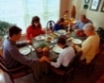Table Prayer

Now thank we all our God with hearts and hands and voices, who wondrous things has done, in whom this world rejoices; who, from our mothers’ arms, has blest us on our way with countless gifts of love, and still is ours today.

*Description: j0199727*Description: MCj03075560000[1] *Stewardship Verse*

*Malachi 3:10*

*Bring the full tithe into the storehouse…and thus put me to the test, says the Lord of hosts; see if I will not open the windows of heaven for you and pour down for you an overflowing blessing.*

Be a good steward of the earth; if you aren’t taking your bulletin home,   
please drop it in the recycling bin in the narthex. Thank you!