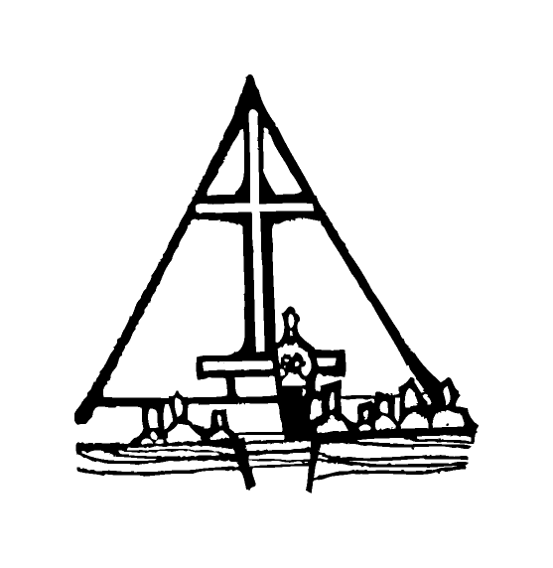Bob Preuss and Amy Oslund, Pastors 1945 Prosperity Road

Leah Bergman, Director of Music Maplewood, MN 55109

Dan Woolley, Organist 651-777-1329

[www.crosslutheranchurch.org](http://www.crosslutheranchurch.org) [cross@pro-ns.net](mailto:cross@pro-ns.net)

***Cross Lutheran Church***

**ALL SAINTS SUNDAY**

**November 2, 2014**

**Evangelical Lutheran Worship Book – Holy Communion Setting Three**

We encourage worshippers to use the time in the sanctuary before the liturgy begins for silent meditation and prayer. The entire assembly will read the Gospel together; pew Bibles can be found in front of you, children’s Bibles and large print lessons are available from the ushers. Prayer for healing and anointing with oil is offered in the narthex during Holy Communion. Any worshipper wishing to receive these gifts may proceed there after receiving the host and the cup, and before returning to the pew.

***Bold Print*** *– indicates congregation responds as a whole*

***\**** *– indicates congregation should stand as able*

**PRELUDE** *Let All Together Praise Our God* Robert Powell

**ANNOUNCEMENTS**

**\*CONFESSION AND FORGIVENESS**  p. 94 (red tab)

**\*OPENING HYMN** *O Day Full of Grace* ELW # 627

**\*GREETING** p. 138

**\*HYMN OF PRAISE** *The Church’s One Foundation* ELW # 654

**\*PRAYER OF THE DAY**

**Almighty God, you have knit your people together in one communion in the mystical body of your Son, Jesus Christ our Lord. Grant us grace to follow your blessed saints in lives of faith and commitment, and to know that inexpressible joys you have prepared for those who love you, through Jesus Christ, our Savior and Lord, who lives and reigns with you and the Holy Spirit, one God, now and forever. Amen.**

**FIRST LESSON** Revelation 7:9-17 N.T. p. 249

**PSALM –** Psalm 34:1-10, 22

*Cantor sings refrain (****R****). The congregation then repeats the refrain in a Round.*

*Congregation responds with the* ***bold verses.***

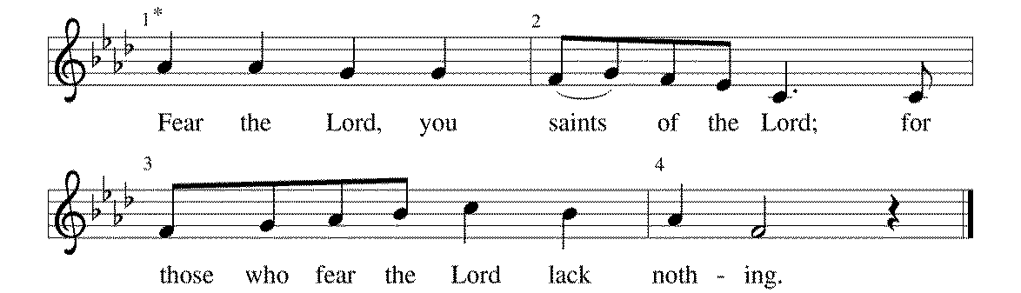



I will bless the Lord | at all times;

the praise of God shall ever be | in my mouth.

2**I will glory | in the Lord;**

**let the lowly hear | and rejoice. R**

3Proclaim with me the greatness | of the Lord;

let us exalt God's | name together.

4**I sought the Lord, who | answered me**

**and delivered me from | all my terrors.**

5Look upon the Lord | and be radiant,

and let not your faces | be ashamed.

6**I called in my affliction, and | the Lord heard me**

**and saved me from | all my troubles. R**

7The angel of the Lord encamps around those who | fear the Lord

and de- | livers them.

8**Taste and see that the | Lord is good;**

**happy are they who take ref- | uge in God!**

9Fear the Lord, you saints | of the Lord,

for those who fear the | Lord lack nothing.

10**The lions are in want and | suffer hunger,**

**but those who seek the Lord lack nothing | that is good.**

22O Lord, you redeem the life | of your servants,

and those who put their trust in you will | not be punished. **R**

**SECOND LESSON** I Corinthians 11:23-26 N.T. p. 173

**\*GOSPEL ACCLAMATION** *Alleluia*p. 142

*(P) The Holy Gospel according to Matthew 5:1-12 N.T. p. 4

**\*(C) Glory to you, O Lord.**

*(P) The Gospel of our Lord.

**\*(C) Praise to you, O Christ.**

**THE SERMON**

**\*HYMN OF THE DAY** *I Come with Joy* ELW # 482

**\*APOSTLES’ CREED** p. 127 (blue tab)

**\*PRAYERS OF THE PEOPLE**

**\*SHARING THE PEACE OF THE LORD**

**OFFERING** *From All That Dwell Below the Skies* Gordon Young

**\*OFFERTORY RESPONSE** *Let the Vineyards* ELW # 184

**\*OFFERING PRAYER**

**Blessed are you, O God, maker of all things. Through your goodness you have blessed us with these gifts: our selves, our time, and our possessions. Use us, and what we have gathered, in feeding the world with your love, through the one who gave himself for us, Jesus Christ, our Savior and Lord. Amen.**

**\*WORDS OF INSTITUTION**

**\*THE LORD’S PRAYER** p. 145

**DISTRIBUTION**

**To make the distribution of the Lord’s Supper as easy as possible, we ask that people who wish to commune and who use a wheelchair or walker come to the front first to receive the Sacrament.**

**LAMB OF GOD** p. 146

*Shall We Gather at the River* ELW # 423

Lord Jesus, You Shall Be My Song ELW # 808

*Rise Up, O Saints of God!* ELW # 669

*We Are All One in Mission* ELW # 576

*O God, Our Help in Ages Past* ELW # 632

**\*POST COMMUNION HYMN** *Now Thank We All Our God* ELW # 840

**\*POST COMMUNION PRAYER**

**\*BENEDICTION** p. 146

**\*CLOSING HYMN** *For All the Saints* ELW # 422

**\*DISMISSAL** p. 146

**POSTLUDE** *Trumpet Tune in Eb* David Johnson

To Our Guests and Visitors Today: Every baptized believer who is of age is invited to receive the Lord’s Supper as we worship. The invitation is extended to each of us by the Lord himself, because he is the host of the meal. We also believe that he is the meal; that is that “in, with, and under” the bread and wine we do receive the body and blood of Christ, given and shed for us for the forgiveness of sins. Please follow the directions of the ushers if you wish to commune. Children under the age of ten are invited to receive a Word of blessing. ***Worshipers unable to commune at the front of the church…Please register with an usher*** *and a lay minister will bring the Supper to you in your pew*.

###### **THIS WEEK AT CROSS**

**Today**, November 2 9:00am Worship Service

10:30am 75th Anniversary Program and Breakfast Brunch

3:30pm – 7:00pm Roca de Horeb

Monday, November 3 6:30pm 4th Grade The Creed Milestone Class

7:00pm Board of Lay Ministry Meeting

Tuesday, November 4 9:30am – 11:00am Isaiah Bible Study

6:30pm – 8:00pm Isaiah Bible Study

7:30pm Roca de Horeb

Wednesday, November 5 7:00pm Choir Rehearsal

Thursday, November 6 6:00pm United Sisters Dinner and Meeting

6:30pm 5th Grade First Communion Milestone Class

6:30pm Worship Service at The Shores of Lake Phalen

Friday, November 7 6:00pm – 10:00pm Roca de Horeb

Saturday, November 8 6:00pm Roca de Horeb

9:30am –12:30pm 7th Day Adventist

10:00am Baking Ministry

5:30pm –8:30pm Roca de Horeb

Sunday, November 9 9:00am Worship Service – FIRST COMMUNION

10:30am Sunday School, TEEN, High School & Adult Education

3:30pm – 7:00pm Roca de Horeb

**Today you will find in the bulletin a table prayer**. We know that our Lord is the source of all blessings, and that it is most fitting for us to give thanks before we eat. Some people always pray the same prayer. Others prefer to pray different prayers – some don’t pray at all. A different prayer will be included each month to help us all in this daily devotion.

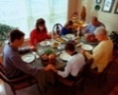Table Prayer

Now thank we all our God with hearts and hands and voices, who wondrous things has done, in whom this world rejoices; who, from our mothers’ arms, has blest us on our way with countless gifts of love, and still is ours today.

*Description: j0199727*Description: MCj03075560000[1] *Stewardship Verse*

*Malachi 3:10*

*Bring the full tithe into the storehouse…and thus put me to the test, says the Lord of hosts; see if I will not open the windows of heaven for you and pour down for you an overflowing blessing.*

Be a good steward of the earth; if you aren’t taking your bulletin home,   
please drop it in the recycling bin in the narthex. Thank you!