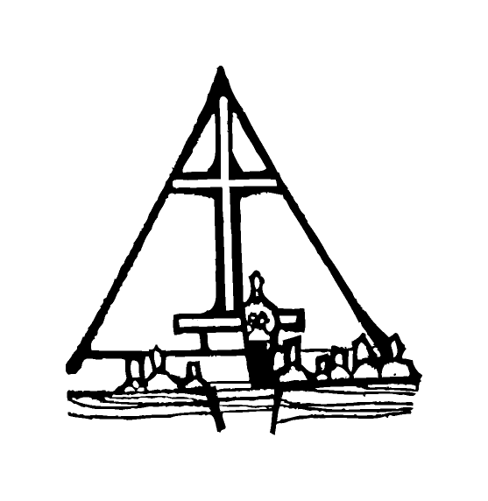Bob Preuss and Amy Oslund, Pastors 1945 Prosperity Road

Leah Bergman, Director of Music Maplewood, MN 55109

Dan Woolley, Organist 651-777-1329

[www.crosslutheranchurch.org](http://www.crosslutheranchurch.org) [cross@pro-ns.net](mailto:cross@pro-ns.net)

***Cross Lutheran Church***

**THE FIRST SUNDAY OF ADVENT**

**November 30, 2014**

**Evangelical Lutheran Worship Book – HYMN SING SERVICE**

We encourage worshippers to use the time in the sanctuary before the liturgy begins for silent meditation and prayer. The entire assembly will read the Gospel together; pew Bibles can be found in front of you, children’s Bibles and large print lessons are available from the ushers. Prayer for healing and anointing with oil is offered in the narthex during Holy Communion. Any worshipper wishing to receive these gifts may proceed there after receiving the host and the cup, and before returning to the pew.

***Bold Print*** *– indicates congregation responds as a whole*

***\**** *– indicates congregation should stand as able*

**PRELUDE**

**ANNOUNCEMENTS**

**LIGHTING OF THE ADVENT CANDLE** *O Come, O Come, Emmanuel Choir Only*

**\*INVOCATION**

**\*CONFESSION AND FORGIVENESS** *Lost in the Night* ELW # 243

**\*OPENING HYMN** *People, Look East* ELW # 248

**\*GREETING** p. 138

**\*KYRIE/HYMN OF PRAISE** *O Lord, How Shall I Meet You*ELW # 241

**Sung to the tune for *All Glory, Laud, and Honor***

**\*PRAYER OF THE DAY**

**Stir up your power, Lord Christ, and come. By your merciful protection awaken us to the threatening dangers of our sins, and keep us blameless until the coming of your new day, for you live and reign with the Father and the Holy Spirit, one God, now and forever. Amen.**

**FIRST LESSON** Isaiah 64:1-9 O.T. p. 694

**PSALM 80:1-7, 17-19**

*Cantor sings refrain (****R****). The congregation then repeats the refrain.*

*Congregation responds with the* ***bold verses.***

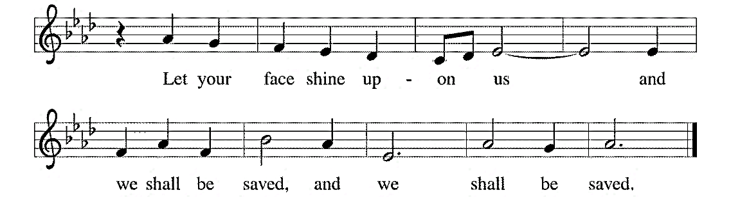



Hear, O Shepherd of Israel, leading Joseph | like a flock;

shine forth, you that are enthroned up- | on the cherubim.

2**In the presence of Ephraim, Benjamin, | and Manasseh,**

**stir up your strength and | come to help us.**

3Restore | us, O God;

let your face shine upon us, and we | shall be saved.

4**O Lord | God of hosts,**

**how long will your anger fume when your | people pray? R**

5You have fed them with the | bread of tears;

you have given them bowls of | tears to drink.

6**You have made us the derision | of our neighbors,**

**and our enemies laugh | us to scorn.**

7Restore us, O | God of hosts;

let your face shine upon us, and we | shall be saved.

17**Let your hand be upon the one at | your right hand,**

**the one you have made so strong | for yourself. R**

18And so will we never turn a- | way from you;

give us life, that we may call up- | on your name.

19**Restore us, O Lord | God of hosts;**

**let your face shine upon us, and we | shall be saved. R**

**SECOND LESSON** I Corinthians 1:3-9 N.T. p. 166

**\*GOSPEL ACCLAMATION** *I Love to Tell the Story*ELW # 661

*(P) The Holy Gospel according to Mark 13:24-37 N.T. p. 50

**\*(C) Glory to you, O Lord.**

*(P) The Gospel of our Lord.

**\*(C) Praise to you, O Christ.**

**THE SERMON**

**\*HYMN OF THE DAY** *Hark, the Glad Sound* ELW # 239

**\*APOSTLES’ CREED** p. 127 (blue tab)

**\*PRAYERS OF THE PEOPLE**

**\*SHARING THE PEACE OF THE LORD**

**OFFERING** *While We Are Waiting, Come*

**\*OFFERTORY RESPONSE** *Praise God, From Whom All Blessings Flow* ELW #884

**\*OFFERING PRAYER**

**Blessed are you, O God, maker of all things. Through your goodness you have blessed us with these gifts: our selves, our time, and our possessions. Use us, and what we have gathered, in feeding the world with your love, through the one who gave himself for us, Jesus Christ, our Savior and Lord. Amen.**

**\*WORDS OF INSTITUTION**

**\*THE LORD’S PRAYER** p. 145

**DISTRIBUTION**

**To make the distribution of the Lord’s Supper as easy as possible, we ask that people who wish to commune and who use a wheelchair or walker come to the front first to receive the Sacrament.**

**LAMB OF GOD** p. 146

*I Come with Joy* ELW # 482

Joyful, Joyful We Adore Thee ELW # 836

Comfort, Comfort Now My People ELW # 256

Canticle of the Turning ELW # 723

**\*POST COMMUNION PRAYER**

**\*BENEDICTION**

**\*CLOSING HYMN** *Prepare the Royal Highway* ELW # 264

**\*DISMISSAL** p. 146

**POSTLUDE**

To Our Guests and Visitors Today: Every baptized believer who is of age is invited to receive the Lord’s Supper as we worship. The invitation is extended to each of us by the Lord himself, because he is the host of the meal. We also believe that he is the meal; that is that “in, with, and under” the bread and wine we do receive the body and blood of Christ, given and shed for us for the forgiveness of sins. Please follow the directions of the ushers if you wish to commune. Children under the age of ten are invited to receive a Word of blessing. ***Worshipers unable to commune at the front of the church…Please register with an usher and a lay minister will bring the Supper to you in your pew*.**

###### **THIS WEEK AT CROSS**

**Today**, November 30 9:00am Worship Service

10:30am Sunday School, TEEN, High School & Adult Education

3:30pm – 7:00pm Roca de Horeb

4:30pm 7th Day Adventist

Monday, December 1 7:00pm Board of Lay Ministry Meeting

Tuesday, December 2 6:30pm Book Club

7:30pm Roca de Horeb at Cross Lutheran

Wednesday, December 3 6:45pm Midweek Advent Worship Service

7:30pm Choir Rehearsal

Thursday, December 4 6:30pm Worship Service at The Shores of Lake Phalen

Friday, December 5 6:00pm – 10:00pm Roca de Horeb

Saturday, December 6 6:00am –8:00am Roca de Horeb

9:30am –12:30pm 7th Day Adventist

5:30pm – 8:30pm Roca de Horeb

Sunday, December 7 9:00am Worship Service

10:30am Sunday School, TEEN, High School & Adult Education

3:30pm – 7:00pm Roca de Horeb

6:00pm – 9:00pm Youth Event – Caroling and Shopping

**Today you will find in the bulletin a table prayer**. We know that our Lord is the source of all blessings, and that it is most fitting for us to give thanks before we eat. Some people always pray the same prayer. Others prefer to pray different prayers – some don’t pray at all. A different prayer will be included each month to help us all in this daily devotion.

Table Prayer

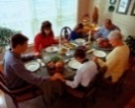Now thank we all our God with hearts and hands and voices, who wondrous things has done, in whom this world rejoices; who, from our mothers’ arms, has blest us on our way with countless gifts of love, and still is ours today.

*Description: j0199727*Description: MCj03075560000[1] *Stewardship Verse*

*Malachi 3:10*

*Bring the full tithe into the storehouse…and thus put me to the test, says the Lord of hosts; see if I will not open the windows of heaven for you and pour down for you an overflowing blessing.*

Be a good steward of the earth; if you aren’t taking your bulletin home,  
please drop it in the recycling bin in the narthex. Thank you!