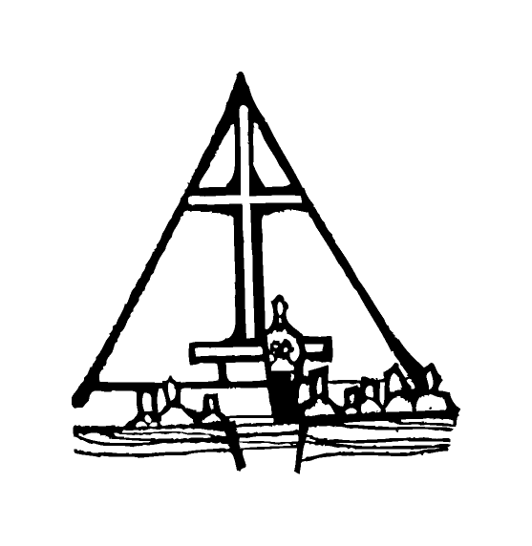Bob Preuss and Amy Oslund, Pastors 1945 Prosperity Road

Leah Bergman, Director of Music Maplewood, MN 55109

Dan Woolley, Organist 651-777-1329

[www.crosslutheranchurch.org](http://www.crosslutheranchurch.org) [cross@pro-ns.net](mailto:cross@pro-ns.net)

***Cross Lutheran Church***

**THE THIRD SUNDAY OF ADVENT**

**December 14, 2014**

**Evangelical Lutheran Worship Book – Holy Communion Setting Three**

We encourage worshippers to use the time in the sanctuary before the liturgy begins for silent meditation and prayer. The entire assembly will read the Gospel together; pew Bibles can be found in front of you, children’s Bibles and large print lessons are available from the ushers. Prayer for healing and anointing with oil is offered in the narthex during Holy Communion. Any worshipper wishing to receive these gifts may proceed there after receiving the host and the cup, and before returning to the pew.

***Bold Print*** *– indicates congregation responds as a whole*

***\**** *– indicates congregation should stand as able*

**PRELUDE** *Offertoire* Marcel Dupre

**ANNOUNCEMENTS**

**LIGHTING OF THE ADVENT CANDLE** *O Come, O Come, Emmanuel Choir Only*

**\*CONFESSION AND FORGIVENESS**  p. 94 (red tab)

**\*OPENING HYMN** *Savior of the Nations, Come* ELW # 263

**\*GREETING** p. 138

**\*KYRIE** p. 138

**\*HYMN OF PRAISE** *Glory to God* p. 139

**\*PRAYER OF THE DAY**

**Stir up the wills of your faithful, people, Lord God, and open our ears to the words of your prophets, that, anointed by your Spirit, we may testify to your light; through Jesus Christ, our Savior and Lord, who lives and reigns with you and the Holy Spirit, one God, now and forever. Amen.**

**FIRST LESSON** Isaiah 61:1-4, 8-11 O.T. p. 691

**PSALM –** Psalm 126

*Cantor sings refrain (****R****). The congregation then repeats the refrain.*

*Congregation responds with the* ***bold verses.***

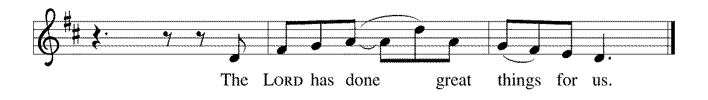



1When the Lord restored the for- | tunes of Zion,

then were we like | those who dream.

2**Then was our mouth filled with laughter,**

**and our tongue with | shouts of joy.**

**Then they said among the nations,**

**"The LORD has done great | things for them."**

3The LORD has done great | things for us,

and we are | glad indeed.

4**Restore our for- | tunes, O LORD,**

**like the watercourses | of the Negeb. R**

5Those who | sowed with tears

will reap with | songs of joy.

6**Those who go out weeping, carry- | ing the seed,**

**will come again with joy, shoulder- | ing their sheaves. R**

**SECOND LESSON** I Thessalonians 5:16-24 N.T. p. 205

**\*GOSPEL ACCLAMATION** *Alleluia*p. 142

*(P) The Holy Gospel according to John 1:6-8, 19-28 N.T. p. 91

**\*(C) Glory to you, O Lord.**

*(P) The Gospel of our Lord.

**\*(C) Praise to you, O Christ.**

**THE SERMON**

**\*HYMN OF THE DAY** *On Jordan’s Bank the Baptist’s Cry* ELW # 249

**\*APOSTLES’ CREED** p. 127 (blue tab)

**\*PRAYERS OF THE PEOPLE**

**\*SHARING THE PEACE OF THE LORD**

**OFFERING** *There’s a Star in the East* African American Spiritual

**\*OFFERTORY RESPONSE** *Let the Vineyards* ELW # 184

**\*OFFERING PRAYER**

**Blessed are you, O God, maker of all things. Through your goodness you have blessed us with these gifts: our selves, our time, and our possessions. Use us, and what we have gathered, in feeding the world with your love, through the one who gave himself for us, Jesus Christ, our Savior and Lord. Amen.**

**\*WORDS OF INSTITUTION**

**\*THE LORD’S PRAYER** p. 145

**DISTRIBUTION**

**To make the distribution of the Lord’s Supper as easy as possible, we ask that people who wish to commune and who use a wheelchair or walker come to the front first to receive the Sacrament.**

**LAMB OF GOD** p. 146

*O Come, O Come, Emmanuel* ELW # 257

**Verses 1, 4, 5, 8**

Away in a Manger ELW # 277

*Your Little Ones, Dear Lord* ELW # 286

*That Boy-Child of Mary* ELW # 293

**\*POST COMMUNION PRAYER**

**\*BENEDICTION** p. 146

**\*CLOSING HYMN** *Hark, the Glad Sound!* ELW # 239

**\*DISMISSAL** p. 146

**POSTLUDE** *Pastorale* Maurice Durufle

To Our Guests and Visitors Today: Every baptized believer who is of age is invited to receive the Lord’s Supper as we worship. The invitation is extended to each of us by the Lord himself, because he is the host of the meal. We also believe that he is the meal; that is that “in, with, and under” the bread and wine we do receive the body and blood of Christ, given and shed for us for the forgiveness of sins. Please follow the directions of the ushers if you wish to commune. Children under the age of ten are invited to receive a Word of blessing. ***Worshipers unable to commune at the front of the church…Please register with an usher*** *and a lay minister will bring the Supper to you in your pew*.

###### **THIS WEEK AT CROSS**

**Today**, December 14 9:00am Worship Service

10:30am United Sisters Christmas Brunch

11:15am Sunday School Christmas Program

3:30pm – 7:00pm Roca de Horeb

Monday, December 15 6:30pm Parish Planning Council (PPC) Meeting

***CROSS CURRENTS ARTICLES DUE***

Tuesday, December 16 7:30pm Roca de Horeb

Wednesday, December 17 6:45pm Midweek Advent Worship Service

7:30pm Choir Rehearsal

Thursday, December 18 6:30pm Worship Service at The Shores of Lake Phalen

Friday, December 19 6:00pm – 10:00pm Roca de Horeb

Saturday, December 20 6:00pm Roca de Horeb Fasting

9:30am –12:30pm 7th Day Adventist

5:30pm –1:00am Roca de Horeb Vigil

Sunday, December 21 9:00am Worship Service

10:45am Worship Service at The Homestead

3:30pm – 7:00pm Roca de Horeb

**Today you will find in the bulletin a table prayer**. We know that our Lord is the source of all blessings, and that it is most fitting for us to give thanks before we eat. Some people always pray the same prayer. Others prefer to pray different prayers – some don’t pray at all. A different prayer will be included each month to help us all in this daily devotion.

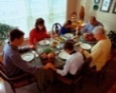Table Prayer

Be near me, Lord Jesus; I ask you to stay close by me forever and love me, I pray. Bless all the dear children in your tender care, and fit us for heaven to live with you there.

*Description: j0199727*Description: MCj03075560000[1] *Stewardship Verse*

*Mark 4:24b-25*

*“The measure you give will be the measure you get, and still more will be given you. For to those who have, more will be given; and from those who have nothing, even what they have will be taken away.”*

Be a good steward of the earth; if you aren’t taking your bulletin home,   
please drop it in the recycling bin in the narthex. Thank you!