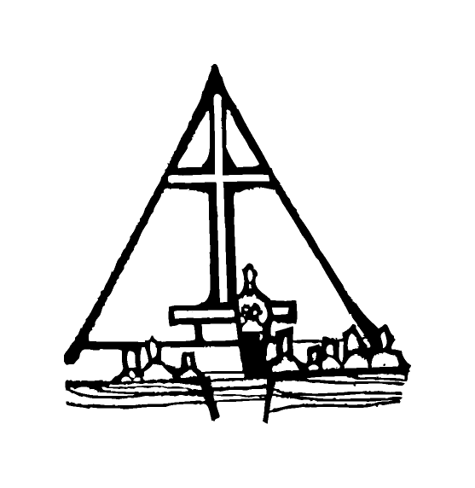Bob Preuss and Amy Oslund, Pastors 1945 Prosperity Road

Leah Bergman, Director of Music Maplewood, MN 55109

Dan Woolley, Organist 651-777-1329

[www.crosslutheranchurch.org](http://www.crosslutheranchurch.org) [cross@pro-ns.net](mailto:cross@pro-ns.net)

***Cross Lutheran Church***

**THE SECOND SUNDAY OF CHRISTMAS**

**January 4, 2015**

**Evangelical Lutheran Worship Book – Holy Communion Setting Three**

We encourage worshippers to use the time in the sanctuary before the liturgy begins for silent meditation and prayer. The entire assembly will read the Gospel together; pew Bibles can be found in front of you, children’s Bibles and large print lessons are available from the ushers. Prayer for healing and anointing with oil is offered in the narthex during Holy Communion. Any worshipper wishing to receive these gifts may proceed there after receiving the host and the cup, and before returning to the pew.

***Bold Print*** *– indicates congregation responds as a whole*

***\**** *– indicates congregation should stand as able*

**PRELUDE**

**ANNOUNCEMENTS**

**\*CONFESSION AND FORGIVENESS**  p. 94 (red tab)

**\*OPENING HYMN** *All My Heart Again Rejoices* ELW # 273

**\*GREETING** p. 138

**\*KYRIE** p. 138

**\*HYMN OF PRAISE** *Let All Together Praise Our God* ELW # 287

**\*PRAYER OF THE DAY**

**Almighty God, you have filled all the earth with the light of your incarnate Word. By your grace empower us to reflect your light in all that we do, through Jesus Christ, our Savior and Lord, who lives and reigns with you and the Holy Spirit, one God, now and forever. Amen.**

**FIRST LESSON** Jeremiah 31:7-14 O.T. p. 734

**PSALM –** Psalm 147:12-20

*Cantor sings refrain (****R****). The congregation then repeats the refrain.*

*Congregation responds with the* ***bold verses.***

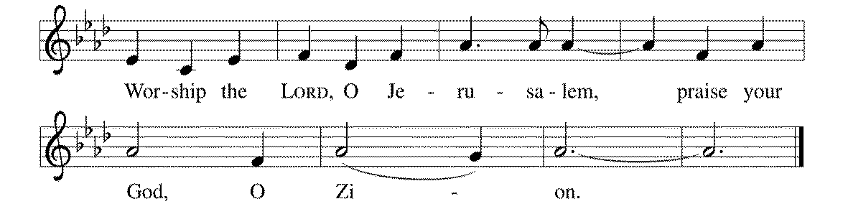



12Worship the LORD, | O Jerusalem;

praise your | God, O Zion,

13**who has strengthened the bars | of your gates**

**and has blessed your chil- | dren within you.**

14God has established peace | on your borders

and satisfies you with the | finest wheat.

15**God sends out a command | to the earth,**

**a word that runs | very swiftly. R**

16God gives | snow like wool,

scattering | frost like ashes.

17**God scatters | hail like bread crumbs.**

**Who can stand a- | gainst God's cold?**

18The LORD sends forth the | word and melts them;

the wind blows, and the | waters flow.

19**God declares the | word to Jacob,**

**statutes and judg- | ments to Israel.**

20The LORD has not done so to any | other nation;

they do not know God's judgments. | Hallelujah! **R**

**SECOND LESSON** Revelation 12:1-17 N.T. p. 252

**\*GOSPEL ACCLAMATION** *Alleluia*p. 142

*(P) The Holy Gospel according to John 1:10-18 N.T. p. 91

**\*(C) Glory to you, O Lord.**

*(P) The Gospel of our Lord.

**\*(C) Praise to you, O Christ.**

**THE SERMON**

**\*HYMN OF THE DAY** *My Life Flows On in Endless Song* ELW # 763

**\*NICENE CREED** p. 126 (blue tab)

**\*PRAYERS OF THE PEOPLE**

**\*SHARING THE PEACE OF THE LORD**

**OFFERING**

**\*OFFERTORY RESPONSE** *Let the Vineyards* ELW # 184

**\*OFFERING PRAYER**

**Blessed are you, O God, maker of all things. Through your goodness you have blessed us with these gifts: our selves, our time, and our possessions. Use us, and what we have gathered, in feeding the world with your love, through the one who gave himself for us, Jesus Christ, our Savior and Lord. Amen.**

**\*WORDS OF INSTITUTION**

**\*THE LORD’S PRAYER** p. 145

**DISTRIBUTION**

**To make the distribution of the Lord’s Supper as easy as possible, we ask that people who wish to commune and who use a wheelchair or walker come to the front first to receive the Sacrament.**

**LAMB OF GOD** p. 146

*O Come, All Ye Faithful* ELW # 283

*As with Gladness Men of Old* ELW # 302

The First Noel ELW # 300

*Of the Father’s Love Begotten* ELW # 295

**\*POST COMMUNION PRAYER**

**\*BENEDICTION** p. 146

**\*CLOSING HYMN** *Brightest and Best of the Stars* ELW # 303

**\*DISMISSAL** p. 146

**POSTLUDE**

To Our Guests and Visitors Today: Every baptized believer who is of age is invited to receive the Lord’s Supper as we worship. The invitation is extended to each of us by the Lord himself, because he is the host of the meal. We also believe that he is the meal; that is that “in, with, and under” the bread and wine we do receive the body and blood of Christ, given and shed for us for the forgiveness of sins. Please follow the directions of the ushers if you wish to commune. Children under the age of ten are invited to receive a Word of blessing. ***Worshipers unable to commune at the front of the church…Please register with an usher*** *and a lay minister will bring the Supper to you in your pew*.

###### **THIS WEEK AT CROSS**

**Today**, January 4 9:00am Worship Service

10:30am Board of Church Properties Meeting

3:30pm – 7:00pm Roca de Horeb

Monday, January 5 7:00pm Board of Lay Ministry Meeting

Tuesday, January 6 6:45pm – 8:00pm Live, Learn and Share Bible Study

7:30pm Roca de Horeb

Wednesday, January 7 6:30pm Confirmation Class

7:00pm Choir Rehearsal

Thursday, January 8 3:30pm Bible Study at The Shores of Lake Phalen

5:30pm Serve at the Family Center

6:30pm Worship Service at The Shores of Lake Phalen

Friday, January 9 6:00pm – 10:00pm Roca de Horeb

Saturday, January 10 6:00am Roca de Horeb

9:30am –12:30pm 7th Day Adventist

1:00pm Church Un-Decorating

5:30pm –8:30pm Roca de Horeb

Sunday, January 11 9:00am Worship Service

10:30am Sunday School

10:45am Worship at The Homestead of Maplewood

12:00pm Parish Planning Council (PPC) Meeting

3:30pm – 7:00pm Roca de Horeb

**Today you will find in the bulletin a table prayer**. We know that our Lord is the source of all blessings, and that it is most fitting for us to give thanks before we eat. Some people always pray the same prayer. Others prefer to pray different prayers – some don’t pray at all. A different prayer will be included each month to help us all in this daily devotion.

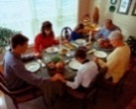Table Prayer

Lord bless this food may it nourish our bodies. Bless the hands that prepared it. Bless this time we have together with family and friends. For all this we owe you in your name, Jesus Christ. Amen.

Description: MCj03075560000[1]*Description: j0199727* *Stewardship Verse*

*Ephesians 4:11-12*

*The gifts he gave were that some would be apostles, some prophets, some evangelists, some pastors and teachers, to equip the saints for the work of ministry, for building up the body of Christ.*

Be a good steward of the earth; if you aren’t taking your bulletin home,   
please drop it in the recycling bin in the narthex. Thank you!