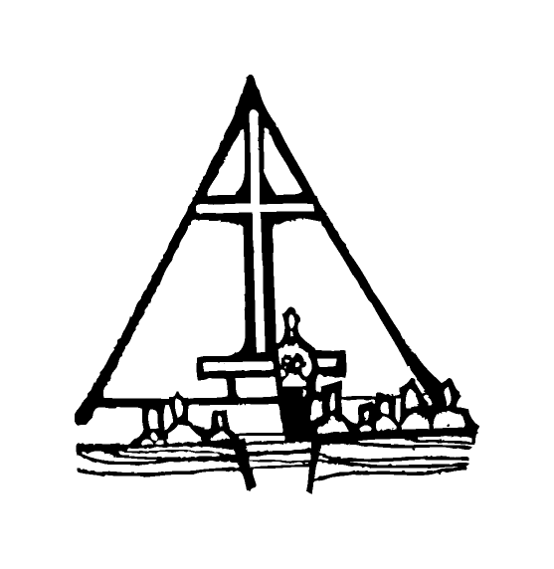Bob Preuss and Amy Oslund, Pastors 1945 Prosperity Road

Leah Bergman, Director of Music Maplewood, MN 55109

Dan Woolley, Organist 651-777-1329

www.crosslutheranchurch.org [cross@pro-ns.net](mailto:cross@pro-ns.net)

***Cross Lutheran Church***

**THE FIFTH SUNDAY AFTER EPIPHANY**

**February 8, 2015**

**ALTERNATIVE SERVICE**

**Our Mission Statement**

**Cross Lutheran Church is a community of believers united by our baptism into Christ Jesus. We are committed to proclaiming and teaching the Good News of God’s love and sharing His love by serving our neighbors in all we do. We invite all to be a part of our fellowship as we grow in grace and follow Christ.**

***Bold Print*** *– indicates congregation responds as a whole*

***\**** *– indicates congregation should stand as able*

**GATHERING SONGS**

**ANNOUNCEMENTS**

**\*CONFESSION AND FORGIVENESS** *You Are Mine*p. 1

**\*OPENING HYMN** *Gather Us In* RB # 28

**CALL TO WORSHIP** *O God in Heaven*p. 2

**\*GOD’S CALL TO US** *Go, Make Disciples* p. 3

**\*PRAYER OF THE DAY**

**Everlasting God, you give strength to the weak and power to the faint. Make us agents of your healing and wholeness, that your good news may be made known to the ends of your creation, through Jesus Christ, our Savior and Lord. Amen.**

**FIRST LESSON** Isaiah 40:21-31 O.T. p. 668

Be a good steward of the earth; if you aren’t taking your bulletin home,   
please drop it in the recycling bin in the narthex. Thank you!

**PSALM 147:1-11**

*Cantor sings refrain (****R****). The congregation then repeats the refrain.*

*Congregation responds with the* ***bold verses.***

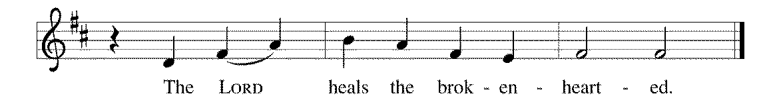



1Hallelujah! How good it is to sing praises | to our God!

How pleasant it is to honor | God with praise!

2**The LORD re- | builds Jerusalem,**

**and gathers the ex- | iles of Israel.**

3The LORD heals the | brokenhearted

and binds | up their wounds.

4**The LORD counts the number | of the stars**

**and calls them all | by their names. R**

5Great is our LORD and might- | y in power;

there is no limit | to God's wisdom.

6**The LORD lifts | up the lowly,**

**but casts the wicked | to the ground.**

7Sing to the LORD | with thanksgiving;

make music upon the harp | to our God,

8**who covers the heav- | ens with clouds**

**and prepares rain for the earth,**

**making grass to grow up- | on the mountains. R**

9God provides food | for the cattle

and for the young ravens | when they cry.

10**God is not impressed by the might | of a horse,**

**and has no pleasure in the speed | of a runner,**

11but finds pleasure in those who | fear the LORD,

in those who await God’s steadfast love. | Hallelujah! **R**

**SECOND LESSON** I Corinthians 9:16-23 N.T. p. 171

**\*GOSPEL ACCLAMATION** *The God of Heaven Thunders* p. 3

**\*GOSPEL** Mark 1:29-39 N.T. p. 35

**THE SERMON**

**\*HYMN OF THE DAY** *When We Are Living*ELW # 639

**Solo Verse sung in Spanish first**

**Congregation sings verses 1-3 following the solo**

**\*APOSTLES’ CREED** *I Believe in God the Father*p. 4

**\*PRAYERS OF THE PEOPLE WITH SUNG RESPONSE** p. 5

**\*SHARING THE PEACE OF THE LORD**

**OFFERING**

**\*OFFERTORY RESPONSE** *Give Thanks with a Grateful Heart* p. 5

**\*WORDS OF INSTITUTION** p. 6

**\*THE LORD’S PRAYER**

**DISTRIBUTION**

**To make the distribution of the Lord’s Supper as easy as possible, we ask that people who wish to commune and who use a wheelchair or walker come to the front first to receive the Sacrament.**

**ANNOINTING**

**Prayer for healing and anointing with oil is offered in the narthex during Holy Communion. Any worshipper wishing to receive these gifts may proceed there after receiving the host and the cup, and before returning to the pew.**

**LAMB OF GOD** *Now Behold the Lamb of God* p. 6

*Here Is Bread* RB # 57

*Borning Cry* RB # 22

*Seek Ye First* RB # 20

*We Are Called* RB # 65 *Jesus Loves Me!* RB # 82

**\*POST COMMUNION PRAYER** p. 6

**\*BENEDICTION** p. 6

**\*CLOSING HYMN***Shine, Jesus, Shine*RB # 21

\***DISMISSAL** p. 7

**\*POSTLUDE** *You Are Mine* p. 7

To Our Guests and Visitors Today: Every baptized believer who is of age is invited to receive the Lord’s Supper as we worship. The invitation is extended to each of us by the Lord himself, because he is the host of the meal. We also believe that he is the meal; that is that “in, with, and under” the bread and wine we do receive the body and blood of Christ, given and shed for us for the forgiveness of sins. Please follow the directions of the ushers if you wish to commune. Children under the age of ten are invited to receive a Word of blessing. ***Worshipers unable to commune at the front of the church****…Please register with an usher and a lay minister will bring the Supper to you in your pew*.

###### **THIS WEEK AT CROSS**

Sunday, February 8 9:30am Worship Service

**10:45am Sunday School, TEEN/High School**

**11:00am Adult Education**

12:00pm – 2:30pm Safeguarding God’s Children

3:30pm – 8:30pm Roca de Horeb

Monday, February 9 7:00pm Board of Education Meeting

Tuesday, February 10 4:00pm – 6:30pm Homework & Hotdish – John Glenn

6:00pm Board of Stewardship Meeting

6:45pm – 8:00pm Live, Learn and Share Bible Study

7:30pm Roca de Horeb

Wednesday, February 11 6:30pm Confirmation Class

7:00pm Choir Rehearsal

Thursday, February 12 3:30pm Bible Study at The Shores of Lake Phalen

5:30pm Serve at the Family Service Center

6:30pm Worship Service at The Shores of Lake Phalen

6:30pm Leave for Gustavus Adolphus – Pre. Conf. Retreat

Friday, February 13 6:00pm – 10:00pm Roca de Horeb

6:30pm – 9:00pm 7th Day Adventist’s Party – Cross Lutheran

Saturday, February 14 6:00am – 8:00am Roca de Horeb

9:30am –12:30pm 7th Day Adventist

3:00pm Return from Gustavus Adolphus

5:30pm –8:30pm Roca de Horeb

Sunday, February 15 9:30am Worship Service

10:45am Sunday School Classes

11:00am Worship Service at The Homestead

3:30pm – 8:30pm Roca de Horeb

5:00pm 7th Day Adventist

***CROSS CURRENTS ARTICLES DUE***

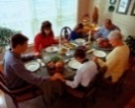**Today you will find in the bulletin a table prayer**. We know that our Lord is the source of all blessings, and that it is most fitting for us to give thanks before we eat. Some people always pray the same prayer. Others prefer to pray different prayers – some don’t pray at all. A different prayer will be included each month to help us all in this daily devotion.

Table Prayer

Description: MCj03075560000[1]Our health is given by this food; our food, dear Lord, comes by your grace. Our thanks we offer in return at every meal, in every place. Amen.

*Description: j0199727* *Stewardship Verse*

*Micah 6:6a, 8*

*With what shall I come before the Lord, and bow myself before God on high?He has told you, O mortal, what is good; and what does the Lord require of you but to do justice, and to love kindness, and to walk humbly with your God?*