Bob Preuss and Amy Oslund, Pastors 1945 Prosperity Road

Leah Bergman, Director of Music Maplewood, MN 55109

Dan Woolley, Organist 651-777-1329

www.crosslutheranchurch.org [cross@pro-ns.net](mailto:cross@pro-ns.net)

***Cross Lutheran Church***

**THE SECOND SUNDAY OF EASTER**

**April 12, 2015**

**ALTERNATIVE SERVICE**

**Our Mission Statement**

**Cross Lutheran Church is a community of believers united by our baptism into Christ Jesus. We are committed to proclaiming and teaching the Good News of God’s love and sharing His love by serving our neighbors in all we do. We invite all to be a part of our fellowship as we grow in grace and follow Christ.**

***Bold Print*** *– indicates congregation responds as a whole*

***\**** *– indicates congregation should stand as able*

**GATHERING SONGS**

**ANNOUNCEMENTS**

**\*CONFESSION AND FORGIVENESS** *You Are Mine*p. 1

**\*OPENING HYMN** *Alleluia! Jesus is Risen!* RB # 35

**CALL TO WORSHIP** *O God in Heaven*p. 2

**\*GOD’S CALL TO US** *Go, Make Disciples* p. 3

**\*PRAYER OF THE DAY**

**Almighty God, with joy we celebrate the day of our Lord’s resurrection. By the grace of Christ among us, enable us to show the power of the resurrection in all that we say and do, through Jesus Christ, our Savior and Lord, who lives and reigns with you and the Holy Spirit, one God, now and forever. Amen.**

**FIRST LESSON** Acts 4:32-35 N.T. p. 122

**PLEASE SILENCE CELL PHONES C:\Users\Kat\AppData\Local\Microsoft\Windows\Temporary Internet Files\Content.IE5\ASZIDIZN\MC900389290[1].wmf NO PHOTOGRAPHYC:\Users\Kat\AppData\Local\Microsoft\Windows\Temporary Internet Files\Content.IE5\6QDW06RI\MC900389436[1].wmf**

**PSALM 133**

*Cantor sings refrain (****R****). The congregation then repeats the refrain.*

*Congregation responds with the* ***bold verses.***

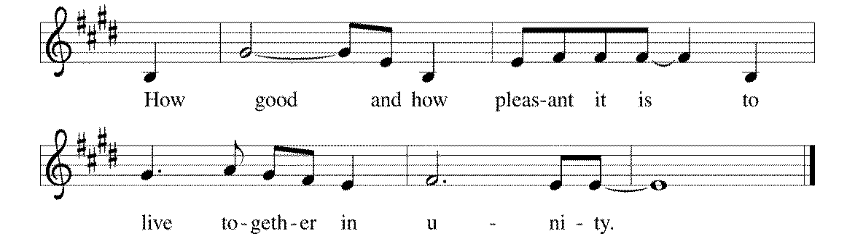



1How good and how pleas- | ant it is,

when kindred live togeth- | er in unity!

2**It is like fine oil upon the head, flowing down up- | on the beard,**

**upon the beard of Aaron, flowing down upon the collar | of his robe. R**

3It is like the dew of Hermon flowing down upon the | hills of Zion.

For there the LORD has commanded the blessing: life for- | evermore. **R**

**SECOND LESSON** I John 1:1 – 2:2 N.T. p. 238

**\*GOSPEL ACCLAMATION** *The God of Heaven Thunders* p. 3

**\*GOSPEL** John 20:19-31 N.T. p. 115

**THE SERMON**

**\*HYMN OF THE DAY** *Borning Cry*RB **#** 22

**\*SACRAMENT OF HOLY BAPTISM**

**\*WORD OF WELCOME**

**Cameron, we welcome you to the Lord’s family. We receive you as a fellow member of the body of Christ, a child of the same heavenly Father, and a worker with us in the kingdom of God.**

**\*SHARING THE PEACE OF THE LORD**

**OFFERING** *Day of Arising (#22)*

**\*OFFERTORY RESPONSE** *Give Thanks with a Grateful Heart* p. 5

**\*WORDS OF INSTITUTION** p. 6

**\*THE LORD’S PRAYER**

**DISTRIBUTION**

**To make the distribution of the Lord’s Supper as easy as possible, we ask that people who wish to commune and who use a wheelchair or walker come to the front first to receive the Sacrament.**

**ANNOINTING**

**Prayer for healing and anointing with oil is offered in the narthex during Holy Communion. Any worshipper wishing to receive these gifts may proceed there after receiving the host and the cup, and before returning to the pew.**

**LAMB OF GOD** *Now Behold the Lamb of God* p. 6

*In the Singing* RB #

*We Know That Christ is Raised* RB # 44

*Great is Thy Faithfulness* RB # 81

*Seek Ye First* RB # 20 *Jesus Loves Me!* RB # 82

**\*POST COMMUNION PRAYER** p. 6

**\*BENEDICTION** p. 6

**\*CLOSING HYMN***Christ Has Arisen, Alleluia*ELW #364

\***DISMISSAL** p. 7

**\*POSTLUDE** *You Are Mine* p. 7

To Our Guests and Visitors Today: Every baptized believer who is of age is invited to receive the Lord’s Supper as we worship. The invitation is extended to each of us by the Lord himself, because he is the host of the meal. We also believe that he is the meal; that is that “in, with, and under” the bread and wine we do receive the body and blood of Christ, given and shed for us for the forgiveness of sins. Please follow the directions of the ushers if you wish to commune. Children under the age of ten are invited to receive a Word of blessing. ***Worshipers unable to commune at the front of the church****…Please register with an usher and a lay minister will bring the Supper to you in your pew*.

###### **THIS WEEK AT CROSS**

**Today**, April 12 9:30am Worship Service

10:45am Sunday School Classes

11:00am Worship at The Homestead of Maplewood

3:30pm Roca de Horeb

6:30pm Midwest Mystery Trip Meeting

Tuesday, April 14 6:00pm Stewardship Meeting

7:30pm – 8:30pm Roca de Horeb

Wednesday, April 15 CROSS CURRENTS ARTICLES DUE

6:30pm Confirmation Class

7:00pm Choir Rehearsal

Thursday, April 16 10:00am East Central Conference - Pastors

6:30pm Worship at The Shores of Lake Phalen

7:00pm 7th Day Adventists Prayer Group

Friday, April 17 6:00pm – 9:30pm Roca de Horeb

Saturday, April 18 6:00am – 8:00am Roca de Horeb

9:30am – 12:00pm 7th Day Adventist

5:30pm – 9:00pm Roca de Horeb

Sunday, April 19 9:00am Worship Service

10:45am Sunday School, TEEN/High School

11:00am Adult Education Class

3:30pm – 6:30pm Roca de Horeb

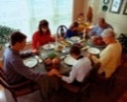**Today you will find in the bulletin a table prayer**. We know that our Lord is the source of all blessings, and that it is most fitting for us to give thanks before we eat. Some people always pray the same prayer. Others prefer to pray different prayers – some don’t pray at all. A different prayer will be included each month to help us all in this daily devotion.

Table Prayer

I thank you now, dear Lord, for my home and friends and food. Help me serve you all this day and show my gratitude. Amen.

Description: MCj03075560000[1]

*Description: j0199727Stewardship Verse*

*Luke 12:32-34*

*“Have no fear, little flock, for it is your Father’s good pleasure to give you the kingdom. Sell your possessions, and give alms. Make purses for yourselves that do not wear out, an unfailing treasure in heaven, where no thief comes near and no moth destroys. For where your treasure is, there your heart will be also.”*

Be a good steward of the earth; if you aren’t taking your bulletin home,   
please drop it in the recycling bin in the narthex. Thank you!