**Alleluia!**

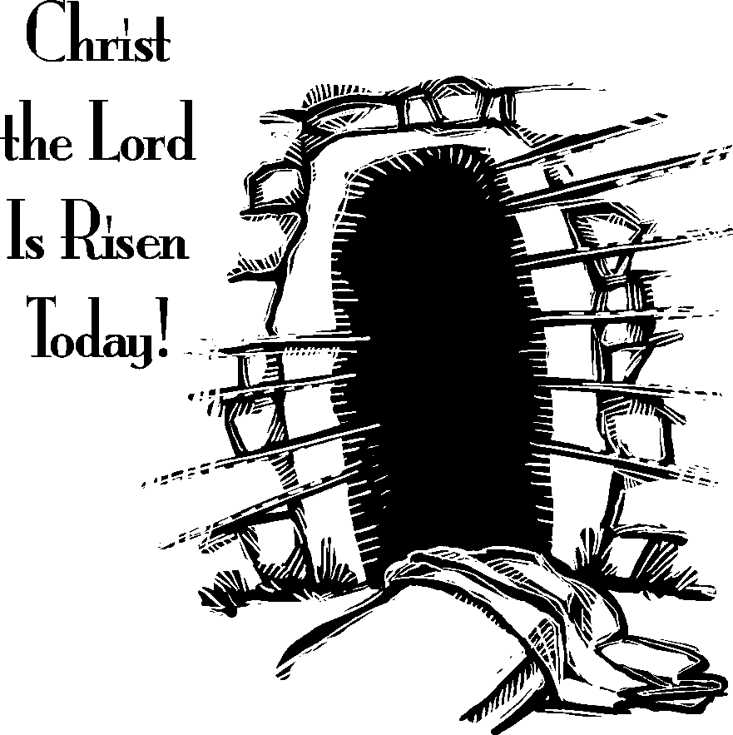

Cross Lutheran Church

**The Resurrection of Our Lord**

**Easter Sunday**

April 5, 2015Bob Preuss and Amy Oslund, Pastors 1945 Prosperity Road

Leah Bergman, Director of Music Maplewood, MN 55109

Dan Woolley, Organist 651-777-1329

[www.crosslutheranchurch.org](http://www.crosslutheranchurch.org) [cross@pro-ns.net](mailto:cross@pro-ns.net)

***Cross Lutheran Church***

**EASTER SUNDAY**

**April 5, 2015**

**Evangelical Lutheran Worship Book – Holy Communion Setting One**

We encourage worshippers to use the time in the sanctuary before the liturgy begins for silent meditation and prayer. The entire assembly will read the Gospel together; pew Bibles can be found in front of you, children’s Bibles and large print lessons are available from the ushers. Prayer for healing and anointing with oil is offered in the narthex during Holy Communion. Any worshipper wishing to receive these gifts may proceed there after receiving the host and the cup, and before returning to the pew.

***Bold Print*** *– indicates congregation responds as a whole*

***\**** *– indicates congregation should stand as able*

**PRELUDE**

**ANNOUNCEMENTS**

**\*CONFESSION AND FORGIVENESS**  p. 94 (red tab)

**\*OPENING HYMN** *Jesus Christ Is Risen Today* ELW # 365

**\*GREETING** p. 98

**\*KYRIE** p. 98

**\*HYMN OF PRAISE** *This is the Feast*p. 101

**\*PRAYER OF THE DAY**

**O God, you gave your only Son to suffer death on the cross for our redemption, and by his glorious resurrection you delivered us from the power of death. Make us die every day to sin, that we may live with him forever in the joy of the resurrection, through your Son, Jesus Christ our Lord, who lives and reigns with you and the Holy Spirit, one God, now and forever. Amen.**

**FIRST LESSON** Acts 10:34-43 N.T. p. 129

**PSALM 118:1-2, 14-25**

*Cantor sings refrain (****R****). The congregation then repeats the refrain.*

*Congregation responds with the* ***bold verses.***

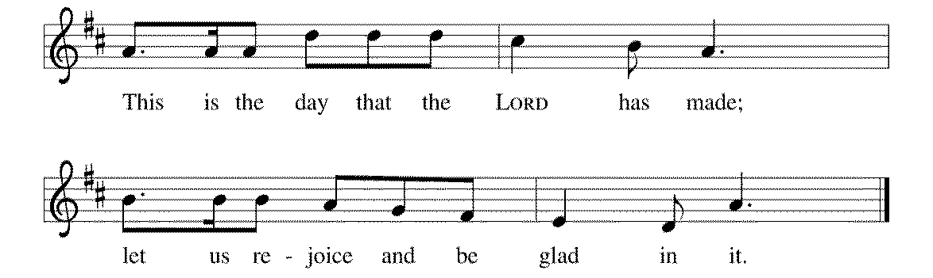

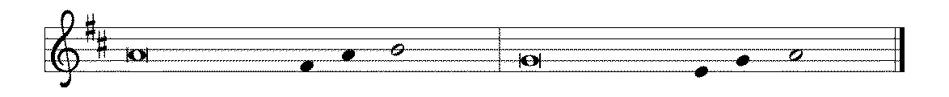

1Give thanks to the LORD, for the | LORD is good;

God's mercy en- | dures forever.

2**Let Israel | now declare,**

**"God's mercy en- | dures forever."**

14The LORD is my strength | and my song,

and has become | my salvation.

15**Shouts of rejoicing and salvation echo in the tents | of the righteous:**

**"The right hand of the | LORD acts valiantly!**

16The right hand of the LORD | is exalted!

The right hand of the | LORD acts valiantly!"

17**I shall not | die, but live,**

**and declare the works | of the LORD. R**

18The LORD indeed pun- | ished me sorely,

but did not hand me o- | ver to death.

19**Open for me the | gates of righteousness;**

**I will enter them and give thanks | to the LORD.**

20"This is the gate | of the LORD;

here the righ- | teous may enter."

21**I give thanks to you, for you have | answered me**

**and you have become | my salvation. R**

22The stone that the build- | ers rejected

has become the chief | cornerstone.

23**By the LORD has | this been done;**

**it is marvelous | in our eyes.**

24This is the day that the | LORD has made;

let us rejoice and be | glad in it. **R**

**SECOND LESSON** I Corinthians 15:1-11 N.T. p. 176

**\*GOSPEL ACCLAMATION** *Alleluia*p. 102

**\*GOSPEL**

*(P) The Holy Gospel according to Mark 16:1-8 N.T. p. 54

**\*(C) Glory to you, O Lord.**

*(P) The Gospel of our Lord.

**\*(C) Praise to you, O Christ.**

**THE SERMON**

**\*HYMN OF THE DAY** *How Firm a Foundation* ELW # 796

**\*NICENE CREED** p.126 (blue tab)

**\*PRAYERS OF THE PEOPLE**

**\*SHARING THE PEACE OF THE LORD**

**OFFERING**

**\*OFFERTORY RESPONSE** *Praise God, from Whom All Blessings Flow* ELW #885

**\*OFFERING PRAYER**

**Blessed are you, O God, maker of all things. Through your goodness you have blessed us with these gifts: our selves, our time, and our possessions. Use us, and what we have gathered, in feeding the world with your love, through the one who gave himself for us, Jesus Christ, our Savior and Lord. Amen.**

**\*GREAT THANKSGIVING** p. 107

**\*HOLY, HOLY, HOLY** p. 108

**\*WORDS OF INSTITUTION**

**\*THE LORD’S PRAYER** p. 112

**DISTRIBUTION**

**To make the distribution of the Lord’s Supper as easy as possible, we ask that people who wish to commune and who use a wheelchair or walker come to the front first to receive the Sacrament.**

**LAMB OF GOD** p. 112

*Now All the Vault of Heaven Resounds* ELW # 367

Lift High the Cross ELW # 660

Now the Green Blade Rises ELW # 379

Hallelujah! Jesus Lives ELW # 380

Beautiful Savior ELW # 838

**\*POST COMMUNION PRAYER**

**\*BENEDICTION** p. 114

**\*CLOSING HYMN** *Good Christian Friends, Rejoice and Sing!* ELW # 385

**\*DISMISSAL** p. 115

**POSTLUDE**

To Our Guests and Visitors Today: Every baptized believer who is of age is invited to receive the Lord’s Supper as we worship. The invitation is extended to each of us by the Lord himself, because he is the host of the meal. We also believe that he is the meal; that is that “in, with, and under” the bread and wine we do receive the body and blood of Christ, given and shed for us for the forgiveness of sins. Please follow the directions of the ushers if you wish to commune. Children under the age of ten are invited to receive a Word of blessing.

***Worshipers unable to commune at the front of the church…***

*Please register with an usher and a lay minister will bring*

*the Supper to you in your pew*.

PREACHER: Pastor Bob Preuss

CELEBRANT: Pastor Amy Oslund

LAY MINISTER: #1 Allison Hawley March #2 Jim Border

ANOINTING MINISTER: Dan Erickson

ACOLYTE: Miranda Haagensen

GREETERS: Dorothy and Harry Linroth

USHERS: Wayne Lund – Captain; Arline Hagen, Dean Davidson,  
Isabel Davidson, Mark Lund

MUSICIANS: Dan Woolley; Leah Bergman; Hearts, Hands and Voices Choir;

Handbell Ensemble; Duane Gudknecht - Trumpet

NURSERY: *Open but no attendant*

###### *The Altar Guild wishes to thank all those listed below for the beautiful*

###### *Easter flowers used during our services today:*

**

✝Darrell and Marie Anderson in memory of our parents

✝ Sherry Batterman and Geri Hauge in memory of our brother Dean Hauge and Peter Batterman

✝ Richard and Dottie Bingman in celebration of Thomas Bingman  
has no vocal cord cancer!

✝ Sharon Crist in memory of my parents Robert and Isabella Wallace  
and nephew Ben Wallace

✝ The Erickson family in memory of   
Bill Lewinski, Kristen Lewinski, Larry Keeling,  
and Tom Featherstone

✝ Carol Fontaine in memory of Pat Fontaine,   
Roy and Beatrice Bjork and family

✝ Sylvia Graham in memory of loved ones

✝ Pat Hagen in memory of Nancy R. Hagen, Michael Jarvis,   
Floyd R. Hagen

✝ Roxy Horrisberger in memory of Delmore Horrisberger

and other family and friends

✝ Gloria and Dick Klassen in memory of parents

✝ McKinnon and Knutsen families in memory of loved ones

✝ Kay Olson in memory of Mom & Dad, Barb and Roger Krummel

✝ Michele Simon and Bob Preuss in memory of

C:\Users\Carol\AppData\Local\Microsoft\Windows\Temporary Internet Files\Low\Content.IE5\A8D3X3U5\MC900365494[1].WMFJean Preuss, Loretta and Ernie Simon

✝ Lenore Ryder in memory of loved ones

✝ Arlo and Kay Stack in memory of Harry and Evelyn Stack,

LuVern and Esther Buck, and Bud Stack

✝ Mary Vatne in celebration of God’s gifts

***Those who purchased Easter plants for our altar may take them home following the Worship Service today.***

We’ll be serving dinner at the Family Service Center on Thursday April 9th, from 5:30-6:00pm. Please sign up in the narthex if you’d like to help out. Please talk to Roxy Horrisberger with any questions.

*Mystery Trip Meeting – Next Sunday April 12th at 6:30pm. Youth are required to attend 3 meetings.*

**Everyone is invited to -**

**Cross Lutheran Youth Group at the Minnesota Twins**

**May 15th – Leave from Church 5:00pm**

**The Twins are playing Tampa Bay and we want to go enjoy a night of outdoor baseball. Tickets are $25 for the family section and include a hot dog and a pop. Anyone younger than 6th Grade must be accompanied by an adult. Sign up by April 12th on the sign on the Youth bulletin board in the narthex.**

***CONFIRMATION RETURNS ON WEDNESDAY APRIL 15th AT 6:30!***

***Family Fun Night***

***John Glenn School Middle School***

***Tuesday April 21 - 2:30pm – 6:00pm***

Volunteers are needed to be at school on Tuesday, April 21 from 2:45–4:00 p.m. or 5:00-6:00 p.m. to help with meal preparation; and from 4:00–5:00 p.m. to play games like Uno, Bingo, Yahtzee, Pictionary, Scrabble, and others. Teachers and members of the school staff will also be on hand to work with us. We realize that this schedule might not be as convenient for those who are not out of work early enough to volunteer; but it seems that this is what will work best for the students. If you are able and willing to help either with meal preparation and/or play games with John Glenn students, please call the church office (651-777-1329) or speak with Pastor Preuss or Michele Simon as soon as possible so that we make suitable plans.

Women of the Evangelical Lutheran Church in America

Spring Meeting of the East Central Cluster

When: Thursday, April 23rd Registration: ($5)/Dessert 6:30; 7:00 Business and Program

Where: St. Mark’s Lutheran Church, 2499 N. Helen St., North St. Paul

Program features an overview of the wide rande of programs at Tubman Family Crisis Center, the largest provider of domestic violence care in Minnesota.

Material Offering: April Baby Basket Drive - The need is especially for **DIAPERS, DIAPERS!**

If you wish to contribute there will be an ELCA blue box in the narthex to receive contributions.

Further information is on the United Sisters bulletin board across from the kitchen.

**Spring Work Day**

**Take a Chance Breakfast**

**Saturday April 25**

We will have Breakfast at 8:00am before our Work Day at 9:00am. This will be a day for outside work projects – power raking, sweeping, trash cleanup, seeding, etc. Please sign up on the yellow sheet in the bulletin so we know how much food is needed.

Book Club meets Tuesday April 28th at 6:30pm. We are reading “*The Piano Tuner”* a novel by Daniel Mason. High School ages through adults are welcome to join us to discuss this month’s book!

*Time to THINK SUMMER!*

*Sunday May 17th – Spring Picnic – Mark your calendars!*

*Tuesday – Thursday June 9th – 11th – God’s Promise Day Camp “Miracles”*

###### **Lenten Coin Folders** may be placed in the basket in the Narthex or in the offering plate. ***Thank you*** to those who have returned them already.

###### **THIS WEEK AT CROSS**

**Easter Sunday**, April 5 7:00am Easter Sunrise Worship Service

7:45am Easter Breakfast

9:30am Easter Festival Worship Service of Holy Communion

11:30am Worship at The Shores of Lake Phalen

3:30pm Roca de Horeb

Monday, April 6 *Church Office Closed*

Tuesday, April 7 7:30pm – 8:30pm Roca de Horeb

Thursday, April 9 3:30pm Bible Study at The Shores of Lake Phalen

5:30pm Serve at the Family Service Center

6:30pm Worship at The Shores of Lake Phalen

7:00pm 7th Day Adventist Prayer Group

Friday, April 10 6:00pm – 9:30pm Roca de Horeb

Saturday, April 11 6:00am – 8:00am Roca de Horeb Fasting

9:30am – 12:00pm 7th Day Adventist

5:30pm – 2:00am Roca de Horeb Vigil

Sunday, April 12 9:30am Alternative Worship Service

10:45am Sunday School Classes

11:00am Worship Service at The Homestead

3:30pm – 6:30pm Roca de Horeb

6:30pm Midwest Mystery Trip Meeting

**Today you will find in the bulletin a table prayer**. We know that our Lord is the source of all blessings, and that it is most fitting for us to give thanks before we eat. Some people always pray the same prayer. Others prefer to pray different prayers – some don’t pray at all. A different prayer will be included each month to help us all in this daily devotion.

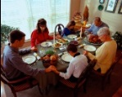Table Prayer

I thank you now, dear Lord, for my home and friends and food. Help me serve you all this day and show my gratitude. Amen.

Description: MCj03075560000[1]

*Description: j0199727Stewardship Verse*

*Luke 12:32-34*

*“Have no fear, little flock, for it is your Father’s good pleasure to give you the kingdom. Sell your possessions, and give alms. Make purses for yourselves that do not wear out, an unfailing treasure in heaven, where no thief comes near and no moth destroys. For where your treasure is, there your heart will be also.”*

Be a good steward of the earth; if you aren’t taking your bulletin home,   
please drop it in the recycling bin in the narthex. Thank you!