Bob Preuss and Amy Oslund, Pastors 1945 Prosperity Road

Leah Bergman, Director of Music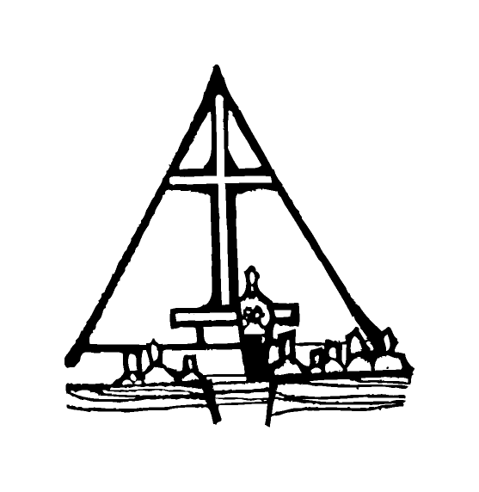 Maplewood, MN 55109

Dan Woolley, Organist 651-777-1329

[www.crosslutheranchurch.org](http://www.crosslutheranchurch.org) [cross@pro-ns.net](mailto:cross@pro-ns.net)

***Cross Lutheran Church***

**THE FOURTH SUNDAY OF EASTER**

**April 26, 2015**

**Evangelical Lutheran Worship Book – Holy Communion Setting One**

We encourage worshippers to use the time in the sanctuary before the liturgy begins for silent meditation and prayer. The entire assembly will read the Gospel together; pew Bibles can be found in front of you, children’s Bibles and large print lessons are available from the ushers. Prayer for healing and anointing with oil is offered in the narthex during Holy Communion. Any worshipper wishing to receive these gifts may proceed there after receiving the host and the cup, and before returning to the pew.

***Bold Print*** *– indicates congregation responds as a whole*

***\**** *– indicates congregation should stand as able*

**PRELUDE**

**ANNOUNCEMENTS**

**\*CONFESSION AND FORGIVENESS**  p. 94 (red tab)

**\*OPENING HYMN** *Crown Him with Many Crowns* ELW # 855

**\*GREETING** p. 98

**\*KYRIE** p. 98

**\*HYMN OF PRAISE** *This is the Feast* p. 101

**\*PRAYER OF THE DAY**

**O Lord Christ, good shepherd of the sheep, you seek the lost and guide us into your fold. Feed us, and we shall be satisfied; heal us, and we shall be whole. Make us one with you, for you live and reign with the Father and the Holy Spirit, one God, now and forever. Amen.**

**FIRST LESSON** Acts 4:5-12 N.T. p. 121

**PLEASE SILENCE CELL PHONES C:\Users\Kat\AppData\Local\Microsoft\Windows\Temporary Internet Files\Content.IE5\ASZIDIZN\MC900389290[1].wmf NO PHOTOGRAPHYC:\Users\Kat\AppData\Local\Microsoft\Windows\Temporary Internet Files\Content.IE5\6QDW06RI\MC900389436[1].wmf**

**PSALM –** Psalm 23

*Cantor sings refrain (****R****). The congregation then repeats the refrain.*

*Congregation responds with the* ***bold verses.***

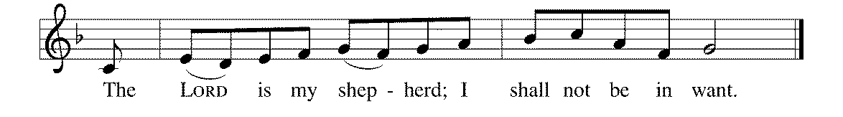



1The LORD | is my shepherd;

I shall not | be in want.

2**The LORD makes me lie down | in green pastures**

**and leads me be- | side still waters.**

3You restore my | soul, O LORD,

and guide me along right pathways | for your name's sake.

4**Though I walk through the valley of the shadow of death, I shall | fear no evil;**

**for you are with me; your rod and your staff, they | comfort me. R**

5You prepare a table before me in the presence | of my enemies;

you anoint my head with oil, and my cup is | running over.

6**Surely goodness and mercy shall follow me all the days | of my life,**

**and I will dwell in the house of the | LORD forever. R**

**SECOND LESSON** I John 3:16-24 N.T. p. 240

**\*GOSPEL ACCLAMATION** *Alleluia*p. 102

**\*GOSPEL RESPONSES** p. 103

**\*GOSPEL**

*(P) The Holy Gospel according to John 10:11-18N.T. p. 103

**\*(C) Glory to you, O Lord.**

*(P) The Gospel of our Lord.

**\*(C) Praise to you, O Christ.**

**THE SERMON**

**\*HYMN OF THE DAY** *Lord Jesus, You Shall Be My Song* ELW # 808

**\*SACRAMENT OF HOLY BAPTISM**

**\*WORD OF WELCOME**

**Lillian, we welcome you to the Lord’s family. We receive you as a fellow member of the body of Christ, a child of the same heavenly Father, and a worker with us in the kingdom of God.**

**\*SHARING THE PEACE OF THE LORD**

**OFFERING** *The Good Shepherd* Zebulon M. Highben

**\*OFFERTORY RESPONSE** *Praise God, from Whom All Blessings Flow* ELW #885

**\*OFFERING PRAYER**  p. 107

**Blessed are you, O God, maker of all things. Through your goodness you have blessed us with these gifts: our selves, our time, and our possessions. Use us, and what we have gathered, in feeding the world with your love, through the one who gave himself for us, Jesus Christ, our Savior and Lord. Amen.**

**\*WORDS OF INSTITUTION**

**\*THE LORD’S PRAYER** p. 112

**DISTRIBUTION**

**To make the distribution of the Lord’s Supper as easy as possible, we ask that people who wish to commune and who use a wheelchair or walker come to the front first to receive the Sacrament.**

**LAMB OF GOD** p. 112

*The King of Love My Shepherd Is*  ELW # 502

*Christ Is Risen! Alleluia!* ELW # 382

*When in Our Music God Is Glorified* ELW # 851

*Amazing Grace* ELW # 779

**\*POST COMMUNION PRAYER**

**\*BENEDICTION** p. 114

**\*CLOSING HYMN** *Alleluia! Sing to Jesus* ELW # 392

**\*DISMISSAL** p. 115

**POSTLUDE**

To Our Guests and Visitors Today: Every baptized believer who is of age is invited to receive the Lord’s Supper as we worship. The invitation is extended to each of us by the Lord himself, because he is the host of the meal. We also believe that he is the meal; that is that “in, with, and under” the bread and wine we do receive the body and blood of Christ, given and shed for us for the forgiveness of sins. Please follow the directions of the ushers if you wish to commune. Children under the age of ten are invited to receive a Word of blessing. ***Worshipers unable to commune at the front of the church…****Please register with an usher and a lay minister will bring the Supper to you in your pew*.

###### **THIS WEEK AT CROSS**

**Today**, April 26 9:30am Worship Service

10:45am Sunday School, TEEN/High School Classes

11:00am Adult Education Class

12:00pm Board of Church Properties Meeting

3:30pm Roca de Horeb

5:00pm 7th Day Adventists

Tuesday, April 28 6:30pm Book Club

7:30pm – 8:30pm Roca de Horeb

Wednesday, April 29 6:30pm Confirmation Class

7:00pm Choir Rehearsal

Thursday, April 30 6:30pm Worship at The Shores of Lake Phalen

7:00pm 7th Day Adventists Prayer Group

Friday, May 1 6:00pm – 9:30pm Roca de Horeb

Saturday, May 2 6:00am – 8:00am Roca de Horeb

9:30am – 12:00pm 7th Day Adventist

5:30pm – 9:00pm Roca de Horeb

Sunday, May 3 9:30am Worship Service

10:45am Sunday School, TEEN/High School Classes

11:00am Adult Education Class

1:30pm – 4:00pm Coffee Room Reserved - Horrisberger

3:30pm – 6:30pm Roca de Horeb

**Today you will find in the bulletin a table prayer**. We know that our Lord is the source of all blessings, and that it is most fitting for us to give thanks before we eat. Some people always pray the same prayer. Others prefer to pray different prayers – some don’t pray at all. A different prayer will be included each month to help us all in this daily devotion.

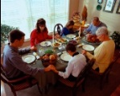

Table Prayer

I thank you now, dear Lord, for my home and friends and food. Help me serve you all this day and show my gratitude. Amen.

Description: MCj03075560000[1]

*Description: j0199727Stewardship Verse*

*Luke 12:32-34*

*“Have no fear, little flock, for it is your Father’s good pleasure to give you the kingdom. Sell your possessions, and give alms. Make purses for yourselves that do not wear out, an unfailing treasure in heaven, where no thief comes near and no moth destroys. For where your treasure is, there your heart will be also.”*

Be a good steward of the earth; if you aren’t taking your bulletin home,  
please drop it in the recycling bin in the narthex. Thank you!