Bob Preuss and Amy Oslund, Pastors 1945 Prosperity Road

Leah Bergman, Director of Music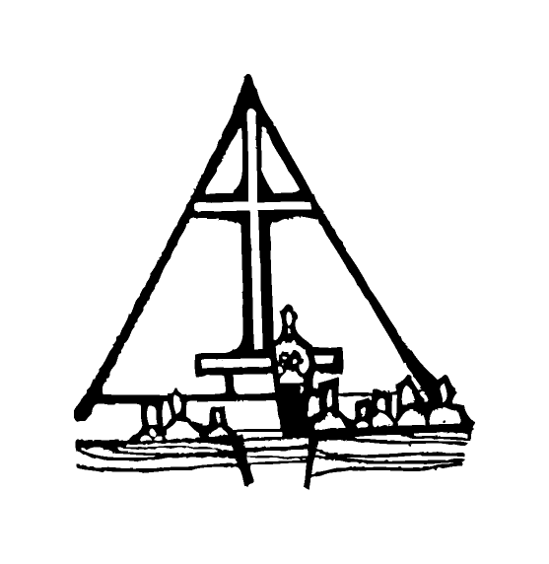 Maplewood, MN 55109

Dan Woolley, Organist 651-777-1329

[www.crosslutheranchurch.org](http://www.crosslutheranchurch.org) [cross@pro-ns.net](mailto:cross@pro-ns.net)

***Cross Lutheran Church***

**THE FIFTH SUNDAY OF EASTER**

**May 3, 2015**

**Evangelical Lutheran Worship Book – Holy Communion Setting One**

We encourage worshippers to use the time in the sanctuary before the liturgy begins for silent meditation and prayer. The entire assembly will read the Gospel together; pew Bibles can be found in front of you, children’s Bibles and large print lessons are available from the ushers. Prayer for healing and anointing with oil is offered in the narthex during Holy Communion. Any worshipper wishing to receive these gifts may proceed there after receiving the host and the cup, and before returning to the pew.

***Bold Print*** *– indicates congregation responds as a whole*

***\**** *– indicates congregation should stand as able*

**PRELUDE** *My Shepherd, You Supply My Need* Robert Holly

**ANNOUNCEMENTS**

**\*CONFESSION AND FORGIVENESS**  p. 94 (red tab)

**\*OPENING HYMN** *Come, Let Us Join Our Cheerful Songs* ELW # 847

**\*GREETING** p. 98

**\*KYRIE** p. 98

**\*HYMN OF PRAISE** *This is the Feast* p. 101

**\*PRAYER OF THE DAY**

**O God, you give us your Son as the vine apart from whom we cannot live. Nourish our life in his resurrection, that we may bear the fruit of love and know the fullness of your joy, through Jesus Christ, our Savior and Lord, who lives and reigns with you and the Holy Spirit, one God, now and forever. Amen.**

**FIRST LESSON** Acts 8:26-40 N.T. p. 127

**PSALM –** Psalm 22:25-31

*Cantor sings refrain (****R****). The congregation then repeats the refrain.*

*Congregation responds with the* ***bold verses.***

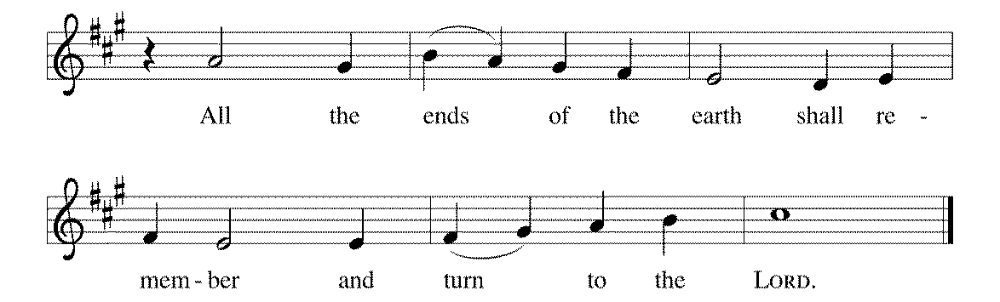

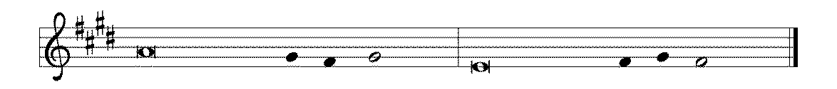

25From you comes my praise in the | great assembly;

I will perform my vows in the sight of those who | fear the LORD.

26**The poor shall eat | and be satisfied.**

**Let those who seek the LORD give praise! May your hearts | live forever!**

27All the ends of the earth shall remember and turn | to the LORD;

all the families of nations shall bow | before God.

28**For dominion belongs | to the LORD,**

**who rules o- | ver the nations. R**

29Indeed, all who sleep in the earth shall bow | down in worship;

all who go down to the dust, though they be dead, shall kneel be- | fore the LORD.

30**Their descendants shall | serve the LORD,**

**whom they shall proclaim to genera- | tions to come.**

31They shall proclaim God's deliverance to a people | yet unborn,

saying to them, "The | LORD has acted!" **R**

**SECOND LESSON** I John 4:7-21 N.T. p. 241

**\*GOSPEL ACCLAMATION** *Alleluia*p. 102

**\*GOSPEL RESPONSES** p. 103

**\*GOSPEL**

*(P) The Holy Gospel according to John 15:1-18N.T. p. 109

**\*(C) Glory to you, O Lord.**

*(P) The Gospel of our Lord.

**\*(C) Praise to you, O Christ.**

**THE SERMON**

**\*HYMN OF THE DAY** *The Risen Christ* ELW # 390

**\*NICENE CREED** p. 126 (blue tab)

**\*PRAYERS OF THE PEOPLE**

**\*SHARING THE PEACE OF THE LORD**

**OFFERING** *I Know That My Redeemer Lives* Paul Cardall

**\*OFFERTORY RESPONSE** *Praise God, from Whom All Blessings Flow* ELW #885

**\*OFFERING PRAYER**  p. 107

**Blessed are you, O God, maker of all things. Through your goodness you have blessed us with these gifts: our selves, our time, and our possessions. Use us, and what we have gathered, in feeding the world with your love, through the one who gave himself for us, Jesus Christ, our Savior and Lord. Amen.**

**\*WORDS OF INSTITUTION**

**\*THE LORD’S PRAYER** p. 112

**DISTRIBUTION**

**To make the distribution of the Lord’s Supper as easy as possible, we ask that people who wish to commune and who use a wheelchair or walker come to the front first to receive the Sacrament.**

**LAMB OF GOD** p. 112

*Good Christian Friends, Rejoice and Sing!* ELW # 385

*Love Divine, All Loves Excelling* ELW # 631

*Lord of All Hopefulness* ELW # 765

*Evening and Morning* ELW # 761

**\*POST COMMUNION PRAYER**

**\*BENEDICTION** p. 114

**\*CLOSING HYMN** *On Our Way Rejoicing* ELW # 537

**\*DISMISSAL** p. 115

**POSTLUDE** *Rock of Ages* Robert Holly

To Our Guests and Visitors Today: Every baptized believer who is of age is invited to receive the Lord’s Supper as we worship. The invitation is extended to each of us by the Lord himself, because he is the host of the meal. We also believe that he is the meal; that is that “in, with, and under” the bread and wine we do receive the body and blood of Christ, given and shed for us for the forgiveness of sins. Please follow the directions of the ushers if you wish to commune. Children under the age of ten are invited to receive a Word of blessing. ***Worshipers unable to commune at the front of the church…****Please register with an usher and a lay minister will bring the Supper to you in your pew*.

###### **THIS WEEK AT CROSS**

**Today**, May 3 9:30am Worship Service

10:45am Sunday School, TEEN/High School Classes

11:00am Adult Education Class

1:30pm – 4:00pm Coffee Room Reserved - Horrisberger

3:30pm Roca de Horeb

6:30pm Midwest Mystery Trip Meeting

Monday, May 4 7:00pm Board of Lay Ministry Meeting

Tuesday, May 5 7:30pm – 8:30pm Roca de Horeb

Wednesday, May 6 6:30pm Confirmation Class

7:00pm Choir Rehearsal

Thursday, May 7 6:30pm Worship at The Shores of Lake Phalen

7:00pm 7th Day Adventists Prayer Group

Friday, May 8 6:00pm – 9:30pm Roca de Horeb

Saturday, May 9 6:00am – 8:00am Roca de Horeb

9:30am – 12:00pm 7th Day Adventist

5:30pm – 9:00pm Roca de Horeb

Sunday, May 10 9:30am Worship Service – Youth Special Offering

10:45am Sunday School, TEEN/High School Classes

11:00am Adult Education Class

3:30pm – 6:30pm Roca de Horeb

**Today you will find in the bulletin a table prayer**. We know that our Lord is the source of all blessings, and that it is most fitting for us to give thanks before we eat. Some people always pray the same prayer. Others prefer to pray different prayers – some don’t pray at all. A different prayer will be included each month to help us all in this daily devotion.

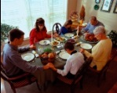

Table Prayer

Gracious Lord, Your Word teaches that veggies with love is a feast. Help us to make harmony and smiles and patience and forgiveness and good listening and good humor the most important food we serve at our table! Please help us to be grateful for whatever food we are served – and to make getting along as important as getting full! Amen.

Description: MCj03075560000[1]

*Description: j0199727Stewardship Verse*

*John 15:16-17*

*“You did not choose me but I chose you. And I appointed you to go and bear fruit, fruit that will last, so that the Father will give you whatever you ask him in my name. I am giving you these commands so that you may love one another.”*

Be a good steward of the earth; if you aren’t taking your bulletin home,  
please drop it in the recycling bin in the narthex. Thank you!