Bob Preuss and Amy Oslund, Pastors 1945 Prosperity Road

Leah Bergman, Director of Music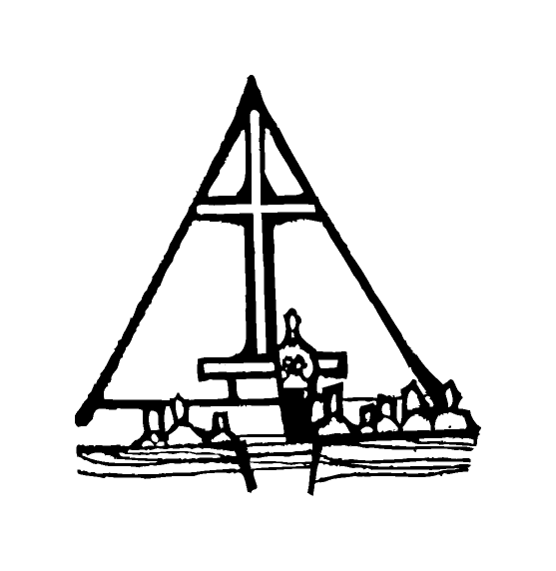 Maplewood, MN 55109

Dan Woolley, Organist 651-777-1329

[www.crosslutheranchurch.org](http://www.crosslutheranchurch.org) [cross@pro-ns.net](mailto:cross@pro-ns.net)

***Cross Lutheran Church***

**THE THIRD SUNDAY AFTER PENTECOST**

**June 14, 2015**

**Evangelical Lutheran Worship Book – Holy Communion Setting One**

We encourage worshippers to use the time in the sanctuary before the liturgy begins for silent meditation and prayer. The entire assembly will read the Gospel together; pew Bibles can be found in front of you, children’s Bibles and large print lessons are available from the ushers. Prayer for healing and anointing with oil is offered in the narthex during Holy Communion. Any worshipper wishing to receive these gifts may proceed there after receiving the host and the cup, and before returning to the pew.

***Bold Print*** *– indicates congregation responds as a whole*

***\**** *– indicates congregation should stand as able*

**PRELUDE**

**ANNOUNCEMENTS**

**\*CONFESSION AND FORGIVENESS**  p. 94 (red tab)

**\*OPENING HYMN** *Oh, Worship the King* ELW # 842

**\*GREETING** p. 98

**\*KYRIE** p. 98

**\*HYMN OF PRAISE** *This is the Feast* p. 101

**\*PRAYER OF THE DAY**

**O God, you are the tree of life, offering shelter to all the world. Graft us into yourself and nurture our growth, that we may bear your truth and love to those in need, through Jesus Christ, our Savior and Lord. Amen.**

**FIRST LESSON** Ezekiel 17:22-24 O.T. p. 784

**PSALM –** Psalm 92:1-4, 12-15

*Cantor sings refrain (****R****). The congregation then repeats the refrain.*

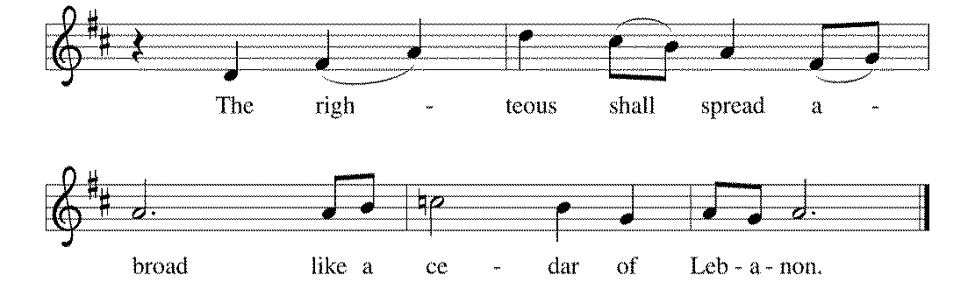 *Congregation responds with the* ***bold verses.***



1It is a good thing to give thanks | to the LORD,

to sing praise to your name, | O Most High;

2**to herald your love | in the morning**

**and your faithful- | ness at night;**

3on the psaltery, and | on the lyre,

and to the melody | of the harp.

4**For you have made me glad by your | acts, O LORD;**

**and I shout for joy because of the works | of your hands. R**

12The righteous shall flourish | like a palm tree,

and shall spread abroad like a ce- | dar of Lebanon.

13**Those who are planted in the house | of the LORD**

**shall flourish in the courts | of our God;**

14they shall still bear fruit | in old age;

they shall be | green and succulent;

15**that they may show how up- | right the LORD is,**

**my rock, in whom there is | no injustice. R**

**SECOND LESSON** II Corinthians 5:6-10, 14-17N.T. p. 181

**\*GOSPEL ACCLAMATION** *Alleluia*p. 102

**\*GOSPEL RESPONSES** p. 103

**\*GOSPEL**

*(P) The Holy Gospel according to Mark 4:26-34 N.T. p. 38

**\*(C) Glory to you, O Lord.**

*(P) The Gospel of our Lord.

**\*(C) Praise to you, O Christ.**

**THE SERMON**

**\*HYMN OF THE DAY** *The Church’s One Foundation* ELW # 654

**\*APOSTLES’ CREED** p. 127 (blue tab)

**\*PRAYERS OF THE PEOPLE**

**\*SHARING THE PEACE OF THE LORD**

**OFFERING**

**\*OFFERTORY RESPONSE** *Praise God, from Whom All Blessings Flow* ELW #885

**\*OFFERING PRAYER**  p. 107

**Blessed are you, O God, maker of all things. Through your goodness you have blessed us with these gifts: our selves, our time, and our possessions. Use us, and what we have gathered, in feeding the world with your love, through the one who gave himself for us, Jesus Christ, our Savior and Lord. Amen.**

**\*WORDS OF INSTITUTION**

**\*THE LORD’S PRAYER** p. 112

**DISTRIBUTION**

**To make the distribution of the Lord’s Supper as easy as possible, we ask that people who wish to commune and who use a wheelchair or walker come to the front first to receive the Sacrament.**

**LAMB OF GOD** p. 112

*We Come to the Hungry Feast* ELW # 479

*God Is Here!* ELW # 526

*O God, Our Help in Ages Past* ELW # 632

*My Hope Is Built on Nothing Less* ELW # 596

**\*POST COMMUNION PRAYER**

**\*BENEDICTION** p. 114

**\*CLOSING HYMN** *Come, Join the Dance of Trinity* ELW # 412

**\*DISMISSAL** p. 115

**POSTLUDE**

To Our Guests and Visitors Today: Every baptized believer who is of age is invited to receive the Lord’s Supper as we worship. The invitation is extended to each of us by the Lord himself, because he is the host of the meal. We also believe that he is the meal; that is that “in, with, and under” the bread and wine we do receive the body and blood of Christ, given and shed for us for the forgiveness of sins. Please follow the directions of the ushers if you wish to commune. Children under the age of ten are invited to receive a Word of blessing. ***Worshipers unable to commune at the front of the church…****Please register with an usher and a lay minister will bring the Supper to you in your pew*.

###### **THIS WEEK AT CROSS**

Sunday, June 14 9:00am Worship Service

10:45am Worship Service at The Homestead of Maplewood

3:30pm – 6:30pm Roca de Horeb

6:30pm – 8:00pm Midwest Mystery Trip Meeting

Monday, June 15 5:30pm Board of Education Meeting

6:30pm Parish Planning Council (PPC) Meeting

6:30pm Tour of the Rain Gardens

CROSS CURRENTS ARTICLES DUE

Tuesday, June 16 7:30pm – 8:30pm Roca de Horeb

Wednesday, June 17 10:30am Bible Study at Bel Rae Senior Living of Mounds View

Thursday, June 18 8:30am Garden Club

3:00pmWorship Service at Bel Rae Senior Living of Mounds View 6:30pm Worship Service at The Shores of Lake Phalen

7:00pm 7th Day Adventists Prayer Group

Friday, June 19 6:00pm – 9:30pm Roca de Horeb

Saturday, June 20 6:00am – 8:00am Roca de Horeb

9:30am – 12:00pm 7th Day Adventist

5:30pm – 9:00pm Roca de Horeb

Sunday, June 21 9:00am Worship Service

10:45am Leave for Confirmation Camp

3:30pm – 6:30pm Roca de Horeb

**Today you will find in the bulletin a table prayer**. We know that our Lord is the source of all blessings, and that it is most fitting for us to give thanks before we eat. Some people always pray the same prayer. Others prefer to pray different prayers – some don’t pray at all. A different prayer will be included each month to help us all in this daily devotion.

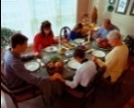Table Prayer

Refresh your people on their toilsome way; Lead us from night to never ending day; Fill all our lives with heaven born love and grace, until at last we meet before your face. Amen.

Description: MCj03075560000[1]*Description: j0199727Stewardship Verse*

*II Corinthians 8:4-5*

*For the churches of Macedonia voluntarily gave according to their means, and even beyond their means, begging us earnestly for the privilege of sharing in this ministry to the saints – and this, not merely as we expected; they gave themselves first to the Lord and, by the will of God, to us.*

Be a good steward of the earth; if you aren’t taking your bulletin home,  
please drop it in the recycling bin in the narthex. Thank you!