Bob Preuss and Amy Oslund, Pastors 1945 Prosperity Road

Leah Bergman, Director of Music Maplewood, MN 55109

Dan Woolley, Organist 651-777-1329

www.crosslutheranchurch.org [cross@pro-ns.net](mailto:cross@pro-ns.net)

***Cross Lutheran Church***

**THE SEVENTH SUNDAY AFTER PENTECOST**

**July 12, 2015**

**ALTERNATIVE SERVICE**

**Our Mission Statement**

**Cross Lutheran Church is a community of believers united by our baptism into Christ Jesus. We are committed to proclaiming and teaching the Good News of God’s love and sharing His love by serving our neighbors in all we do. We invite all to be a part of our fellowship as we grow in grace and follow Christ.**

***Bold Print*** *– indicates congregation responds as a whole*

***\**** *– indicates congregation should stand as able*

**GATHERING SONGS**

**ANNOUNCEMENTS**

**\*CONFESSION AND FORGIVENESS** *You Are Mine*p. 1

**\*OPENING HYMN** *All Are Welcome* RB # 7

**CALL TO WORSHIP** *O God in Heaven*p. 2

**\*GOD’S CALL TO US** *Go, Make Disciples* p. 3

**\*PRAYER OF THE DAY**

**O God, from you come all holy desires, all good counsels, and all just works. Give to us, your servants, that peace which the world cannot give, that our hearts may be set to obey your commandments; and also that we, being defended from the fear of our enemies, may live in peace and quietness, through Jesus Christ, our Savior and Lord. Amen.**

**FIRST LESSON** Amos 7:7-15 O.T. p. 855

**PSALM 85:8-13**

*Cantor sings refrain (****R****). The congregation then repeats the refrain.*

*Congregation responds with the* ***bold verses.***

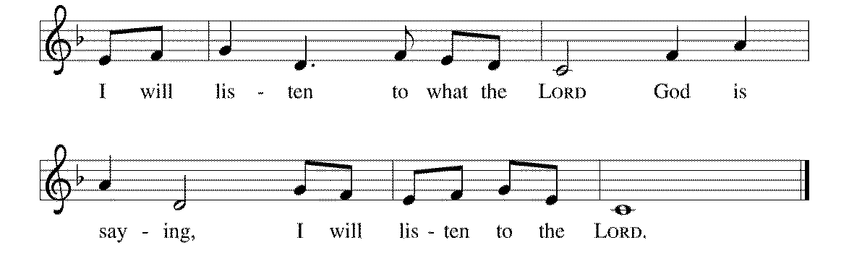



8I will listen to what the LORD | God is saying;

for you speak peace to your faithful people

and to those who turn their | hearts to you.

9**Truly, your salvation is very near to | those who fear you,**

**that your glory may dwell | in our land. R**

10Steadfast love and faithfulness have | met together;

righteousness and peace have | kissed each other.

11**Faithfulness shall spring up | from the earth,**

**and righteousness shall look | down from heaven.**

12The LORD will indeed | grant prosperity,

and our land will | yield its increase.

13**Righteousness shall go be- | fore the LORD**

**and shall prepare for | God a pathway. R**

**SECOND LESSON** Ephesians 1:3-14 N.T. p. 192

**\*GOSPEL ACCLAMATION** *The God of Heaven Thunders* p. 3

**\*GOSPEL** Mark 6:14-29 N.T. p. 40

**THE SERMON**

**\*HYMN OF THE DAY** *When We Are Living*RB # 47

**\*APOSTLES’ CREED** *I Believe in God the Father*p. 4

**\*PRAYERS OF THE PEOPLE WITH SUNG RESPONSE** p. 5

**\*SHARING THE PEACE OF THE LORD**

**OFFERING**

**\*OFFERTORY RESPONSE** *Give Thanks with a Grateful Heart* p. 5

**\*WORDS OF INSTITUTION** p. 6

**\*THE LORD’S PRAYER**

**DISTRIBUTION**

**To make the distribution of the Lord’s Supper as easy as possible, we ask that people who wish to commune and who use a wheelchair or walker come to the front first to receive the Sacrament.**

**ANNOINTING**

**Prayer for healing and anointing with oil is offered in the narthex during Holy Communion. Any worshipper wishing to receive these gifts may proceed there after receiving the host and the cup, and before returning to the pew.**

**LAMB OF GOD** *Now Behold the Lamb of God* p. 6

*In the Singing* RB # 40

*All Around the World* RB # 68

*God of the Sparrow* RB # 17

*Softly and Tenderly* RB # 15

**\*POST COMMUNION PRAYER** p. 6

**\*BENEDICTION** p. 6

**\*CLOSING HYMN***God Be with You Till We Meet Again*RB # 72

\***DISMISSAL** p. 7

**\*POSTLUDE** *You Are Mine* p. 7

To Our Guests and Visitors Today: Every baptized believer who is of age is invited to receive the Lord’s Supper as we worship. The invitation is extended to each of us by the Lord himself, because he is the host of the meal. We also believe that he is the meal; that is that “in, with, and under” the bread and wine we do receive the body and blood of Christ, given and shed for us for the forgiveness of sins. Please follow the directions of the ushers if you wish to commune. Children under the age of ten are invited to receive a Word of blessing. ***Worshipers unable to commune at the front of the church****…Please register with an usher and a lay minister will bring the Supper to you in your pew*.

###### **THIS WEEK AT CROSS**

Sunday, July 12 9:00am Worship Service

10:00am Board of Church Properties Meeting

3:30pm – 6:30pm Roca de Horeb

Monday, July 13 7:00pm Board of Education Meeting

Tuesday, July 14 6:00pm Board of Stewardship Meeting

7:30pm – 8:30pm Roca de Horeb

Thursday, July 16 8:30am Garden Club

3:00pmWorship Service at Bel Rae Senior Living of Mounds View

6:30pm Worship Service at The Shores of Lake Phalen

7:00pm 7th Day Adventists Prayer Group

Friday, July 17 6:00pm – 9:30pm Roca de Horeb

Saturday, July 18 6:00am – 8:00am Roca de Horeb

9:30am – 12:00pm 7th Day Adventist

5:30pm – 9:00pm Roca de Horeb

Sunday, July 19 9:00am Worship Service

10:45am Worship Service at The Homestead of Maplewood

3:30pm – 6:30pm Roca de Horeb

**Today you will find in the bulletin a table prayer**. We know that our Lord is the source of all blessings, and that it is most fitting for us to give thanks before we eat. Some people always pray the same prayer. Others prefer to pray different prayers – some don’t pray at all. A different prayer will be included each month to help us all in this daily devotion.

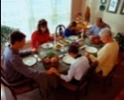Table Prayer

Our health is given by this food; our food, dear Lord, comes by your grace. Our thanks we offer in return at every meal, in every place. Amen.

Description: MCj03075560000[1]*Description: j0199727Stewardship Verse*

*Matthew 6:19-21*

*“Do not store up for yourselves treasures on earth, where moth and rust consume and where thieves break in and steal; but store up for yourselves treasures in heaven…For where your treasure is, there your heart will be also.”*

Be a good steward of the earth; if you aren’t taking your bulletin home,  
please drop it in the recycling bin in the narthex. Thank you!