Bob Preuss and Amy Oslund, Pastors 1945 Prosperity Road

Leah Bergman, Director of Music Maplewood, MN 55109

Dan Woolley, Organist 651-777-1329

[www.crosslutheranchurch.org](http://www.crosslutheranchurch.org) [cross@pro-ns.net](mailto:cross@pro-ns.net)

***Cross Lutheran Church***

**THE FIFTH SUNDAY AFTER PENTECOST**

**June 28, 2015**

**Evangelical Lutheran Worship Book – Holy Communion Setting One**

We encourage worshippers to use the time in the sanctuary before the liturgy begins for silent meditation and prayer. The entire assembly will read the Gospel together; pew Bibles can be found in front of you, children’s Bibles and large print lessons are available from the ushers. Prayer for healing and anointing with oil is offered in the narthex during Holy Communion. Any worshipper wishing to receive these gifts may proceed there after receiving the host and the cup, and before returning to the pew.

***Bold Print*** *– indicates congregation responds as a whole*

***\**** *– indicates congregation should stand as able*

**PRELUDE**  *Prelude*G. Nivers

**ANNOUNCEMENTS**

**\*CONFESSION AND FORGIVENESS**  p. 94 (red tab)

**\*OPENING HYMN** *Oh, for a Thousand Tongues to Sing* ELW # 886

**\*GREETING** p. 98

**\*KYRIE** p. 98

**\*HYMN OF PRAISE** *This is the Feast* p. 101

**\*PRAYER OF THE DAY**

**Almighty and merciful God, we implore you to hear the prayers of your people. Be our strong defense against all harm and danger, that we may live and grow in faith and hope, through Jesus Christ, our Savior and Lord. Amen.**

**FIRST LESSON** Lamentations 3:22-33 O.T. p. 766

**PSALM –** Psalm 30

*Cantor sings refrain (****R****). The congregation then repeats the refrain.*

*Congregation responds with the* ***bold verses.***

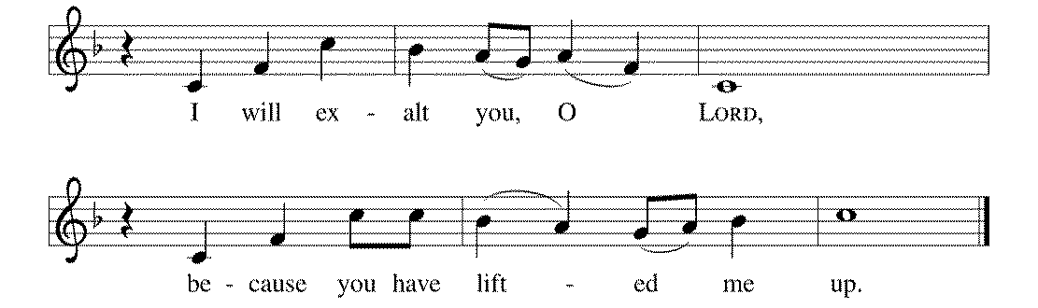



1I will exalt you, O LORD, because you have lift- | ed me up

and have not let my enemies triumph | over me.

2**O LORD my God, I cried | out to you,**

**and you restored | me to health.**

3You brought me up, O LORD, | from the dead;

you restored my life as I was going down | to the grave.

4**Sing praise to the LORD, | all you faithful;**

**give thanks in ho- | ly remembrance. R**

5God's wrath is short; God's favor | lasts a lifetime.

Weeping spends the night, but joy comes | in the morning.

6**While I felt se- | cure, I said,**

**"I shall never | be disturbed.**

7You, LORD, with your favor, made me as strong | as the mountains."

Then you hid your face, and I was | filled with fear.

8**I cried to | you, O LORD;**

**I pleaded with | my LORD, saying,**

9"What profit is there in my blood, if I go down | to the pit?

Will the dust praise you or de- | clare your faithfulness?

10**Hear, O LORD, and have mer- | cy upon me;**

**O LORD, | be my helper." R**

11You have turned my wailing | into dancing;

you have put off my sackcloth and clothed | me with joy.

12**Therefore my heart sings to you | without ceasing;**

**O LORD my God, I will give you | thanks forever. R**

**SECOND LESSON** II Corinthians 8:7-15 N.T. p. 183

**\*GOSPEL ACCLAMATION** *Alleluia*p. 102

**\*GOSPEL RESPONSES** p. 103

**\*GOSPEL**

*(P) The Holy Gospel according to Mark 5:21-43 N.T. p. 39

**\*(C) Glory to you, O Lord.**

*(P) The Gospel of our Lord.

**\*(C) Praise to you, O Christ.**

**THE SERMON**

**\*HYMN OF THE DAY** *Great Is Thy Faithfulness* ELW # 733

**\*APOSTLES’ CREED** p. 127 (blue tab)

**\*PRAYERS OF THE PEOPLE**

**\*SHARING THE PEACE OF THE LORD**

**OFFERING** *Come, Thou Fount of Every Blessing* Arr. Amy Potter

**\*OFFERTORY RESPONSE** *Praise God, from Whom All Blessings Flow* ELW #885

**\*OFFERING PRAYER**  p. 107

**Blessed are you, O God, maker of all things. Through your goodness you have blessed us with these gifts: our selves, our time, and our possessions. Use us, and what we have gathered, in feeding the world with your love, through the one who gave himself for us, Jesus Christ, our Savior and Lord. Amen.**

**\*WORDS OF INSTITUTION**

**\*THE LORD’S PRAYER** p. 112

**DISTRIBUTION**

**To make the distribution of the Lord’s Supper as easy as possible, we ask that people who wish to commune and who use a wheelchair or walker come to the front first to receive the Sacrament.**

**LAMB OF GOD** p. 112

*Let Us Break Bread Together* ELW # 471

*Lead Me, Guide Me* ELW # 768

*My Hope Is Built on Nothing Less* ELW # 596

**\*POST COMMUNION PRAYER**

**\*BENEDICTION** p. 114

**\*CLOSING HYMN** *A Mighty Fortress Is Our God* ELW # 504

**\*DISMISSAL** p. 115

**POSTLUDE** *Magnificat Fuge* Johann Pachelbel

To Our Guests and Visitors Today: Every baptized believer who is of age is invited to receive the Lord’s Supper as we worship. The invitation is extended to each of us by the Lord himself, because he is the host of the meal. We also believe that he is the meal; that is that “in, with, and under” the bread and wine we do receive the body and blood of Christ, given and shed for us for the forgiveness of sins. Please follow the directions of the ushers if you wish to commune. Children under the age of ten are invited to receive a Word of blessing. ***Worshipers unable to commune at the front of the church…****Please register with an usher and a lay minister will bring the Supper to you in your pew*.

###### **THIS WEEK AT CROSS**

Sunday, June 28 9:00am Worship Service

3:30pm – 6:30pm Roca de Horeb

5:00pm 7th Day Adventists

Tuesday, June 30 7:30pm – 8:30pm Roca de Horeb

Thursday, July 2 8:30am Garden Club

3:00pmWorship Service at Bel Rae Senior Living of Mounds View 6:30pm Worship Service at The Shores of Lake Phalen

7:00pm 7th Day Adventists Prayer Group

Friday, July 3 CHURCH OFFICE CLOSED in observance of the 4th of July

6:00pm – 9:30pm Roca de Horeb

Saturday, July 4 ***HAPPY INDEPENDENCE DAY!***

6:00am – 8:00am Roca de Horeb

9:30am – 12:00pm 7th Day Adventist

5:30pm – 9:00pm Roca de Horeb

Sunday, July 5 9:00am Worship Service

3:30pm – 6:30pm Roca de Horeb

**Today you will find in the bulletin a table prayer**. We know that our Lord is the source of all blessings, and that it is most fitting for us to give thanks before we eat. Some people always pray the same prayer. Others prefer to pray different prayers – some don’t pray at all. A different prayer will be included each month to help us all in this daily devotion.

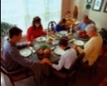Table Prayer

Refresh your people on their toilsome way; Lead us from night to never ending day; Fill all our lives with heaven born love and grace, until at last we meet before your face. Amen.

Description: MCj03075560000[1]*Description: j0199727Stewardship Verse*

*II Corinthians 8:4-5*

*For the churches of Macedonia voluntarily gave according to their means, and even beyond their means, begging us earnestly for the privilege of sharing in this ministry to the saints – and this, not merely as we expected; they gave themselves first to the Lord and, by the will of God, to us.*

Be a good steward of the earth; if you aren’t taking your bulletin home,  
please drop it in the recycling bin in the narthex. Thank you!