Bob Preuss and Amy Oslund, Pastors 1945 Prosperity Road

Leah Bergman, Director of Music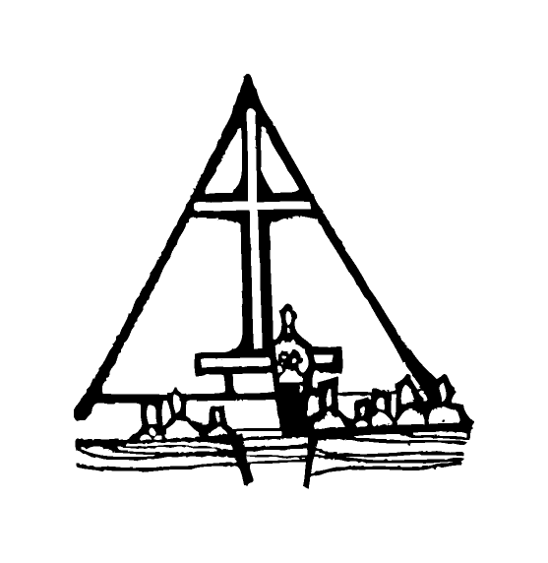 Maplewood, MN 55109

Dan Woolley, Organist 651-777-1329

[www.crosslutheranchurch.org](http://www.crosslutheranchurch.org) [cross@pro-ns.net](mailto:cross@pro-ns.net)

***Cross Lutheran Church***

**THE SIXTH SUNDAY AFTER PENTECOST**

**July 5, 2015**

**Evangelical Lutheran Worship Book – Holy Communion Setting One**

We encourage worshippers to use the time in the sanctuary before the liturgy begins for silent meditation and prayer. The entire assembly will read the Gospel together; pew Bibles can be found in front of you, children’s Bibles and large print lessons are available from the ushers. Prayer for healing and anointing with oil is offered in the narthex during Holy Communion. Any worshipper wishing to receive these gifts may proceed there after receiving the host and the cup, and before returning to the pew.

***Bold Print*** *– indicates congregation responds as a whole*

***\**** *– indicates congregation should stand as able*

**PRELUDE** *Sabbath Day*arr. Marvin Goldstein

**ANNOUNCEMENTS**

**\*CONFESSION AND FORGIVENESS**  p. 94 (red tab)

**\*OPENING HYMN** *Before You, Lord, We Bow* ELW # 893

**\*GREETING** p. 98

**\*KYRIE** p. 98

**\*HYMN OF PRAISE** *This is the Feast* p. 101

**\*PRAYER OF THE DAY**

**God of the covenant, in our baptism you call us to proclaim the coming of your kingdom. Give us the courage you gave the apostles, that we may faithfully witness to your love and peace in every circumstance of life, in the name of Jesus Christ, our Savior and Lord. Amen.**

**FIRST LESSON** Ezekiel 2:1-5 O.T. p. 770

**PSALM –** Psalm 123

*Cantor sings refrain (****R****). The congregation then repeats the refrain.*

*Congregation responds with the* ***bold verses.***

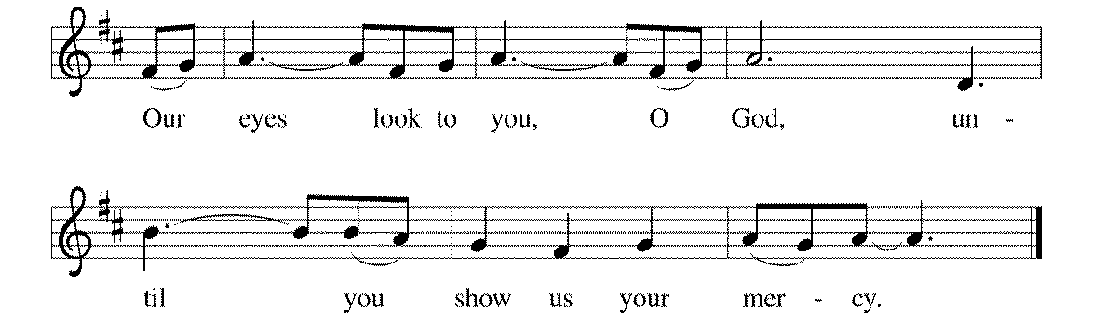



1To you I lift | up my eyes,

to you enthroned | in the heavens.

2**As the eyes of servants look to the hand of their masters,**

**and the eyes of a maid to the hand | of her mistress,**

**so our eyes look to you, O LORD our God,**

**until you show | us your mercy. R**

3Have mercy upon us, O | LORD, have mercy,

for we have had more than enough | of contempt,

4**too much of the scorn of the in- | dolent rich,**

**and of the derision | of the proud. R**

**SECOND LESSON** II Corinthians 12:2-10 N.T. p. 185

**\*GOSPEL ACCLAMATION** *Alleluia*p. 102

**\*GOSPEL RESPONSES** p. 103

**\*GOSPEL**

*(P) The Holy Gospel according to Mark 6:1-13 N.T. p. 40

**\*(C) Glory to you, O Lord.**

*(P) The Gospel of our Lord.

**\*(C) Praise to you, O Christ.**

**THE SERMON**

**\*HYMN OF THE DAY** *Be Thou My Vision* ELW # 793

**\*APOSTLES’ CREED** p. 127 (blue tab)

**\*PRAYERS OF THE PEOPLE**

**\*SHARING THE PEACE OF THE LORD**

**OFFERING** *Abide with Me* arr. Sally DeFord

**\*OFFERTORY RESPONSE** *Praise God, from Whom All Blessings Flow* ELW #885

**\*OFFERING PRAYER**  p. 107

**Blessed are you, O God, maker of all things. Through your goodness you have blessed us with these gifts: our selves, our time, and our possessions. Use us, and what we have gathered, in feeding the world with your love, through the one who gave himself for us, Jesus Christ, our Savior and Lord. Amen.**

**\*WORDS OF INSTITUTION**

**\*THE LORD’S PRAYER** p. 112

**DISTRIBUTION**

**To make the distribution of the Lord’s Supper as easy as possible, we ask that people who wish to commune and who use a wheelchair or walker come to the front first to receive the Sacrament.**

**LAMB OF GOD** p. 112

*Break Now the Bread of Life* ELW # 515

*This Is My Father’s World* ELW # 824

*Take My Life, That I May Be* ELW # 685

**\*POST COMMUNION PRAYER**

**\*BENEDICTION** p. 114

**\*CLOSING HYMN** *God Bless Our Native Land* ELW # 891

**\*DISMISSAL** p. 115

**POSTLUDE** *Postlude* Jon Schmidt

To Our Guests and Visitors Today: Every baptized believer who is of age is invited to receive the Lord’s Supper as we worship. The invitation is extended to each of us by the Lord himself, because he is the host of the meal. We also believe that he is the meal; that is that “in, with, and under” the bread and wine we do receive the body and blood of Christ, given and shed for us for the forgiveness of sins. Please follow the directions of the ushers if you wish to commune. Children under the age of ten are invited to receive a Word of blessing. ***Worshipers unable to commune at the front of the church…****Please register with an usher and a lay minister will bring the Supper to you in your pew*.

###### **THIS WEEK AT CROSS**

Sunday, July 5 9:00am Worship Service

3:30pm – 6:30pm Roca de Horeb

5:00pm 7th Day Adventists

Monday, July 6 7:00pm Board of Lay Ministry Meeting

Tuesday, July 7 7:30pm – 8:30pm Roca de Horeb

Thursday, July 9 8:30am Garden Club

10:30am Bible Study at The Shores of Lake Phalen

3:00pmWorship Service at Bel Rae Senior Living of Mounds View

5:30pm Serve at the Family Service Center

6:30pm Worship Service at The Shores of Lake Phalen

7:00pm 7th Day Adventists Prayer Group

Friday, July 10 6:00pm – 9:30pm Roca de Horeb

Saturday, July 11 6:00am – 8:00am Roca de Horeb

9:30am – 12:00pm 7th Day Adventist

5:30pm – 9:00pm Roca de Horeb

Sunday, July 12 9:00am Worship Service

10:00am Board of Church Properties Meeting

3:30pm – 6:30pm Roca de Horeb

**Today you will find in the bulletin a table prayer**. We know that our Lord is the source of all blessings, and that it is most fitting for us to give thanks before we eat. Some people always pray the same prayer. Others prefer to pray different prayers – some don’t pray at all. A different prayer will be included each month to help us all in this daily devotion.

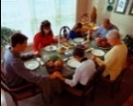Table Prayer

Our health is given by this food; our food, dear Lord, comes by your grace. Our thanks we offer in return at every meal, in every place. Amen.

Description: MCj03075560000[1]*Description: j0199727Stewardship Verse*

*Matthew 6:19-21*

*“Do not store up for yourselves treasures on earth, where moth and rust consume and where thieves break in and steal; but store up for yourselves treasures in heaven…For where your treasure is, there your heart will be also.”*

Be a good steward of the earth; if you aren’t taking your bulletin home,  
please drop it in the recycling bin in the narthex. Thank you!