Bob Preuss and Amy Oslund, Pastors 1945 Prosperity Road

Leah Bergman, Director of Music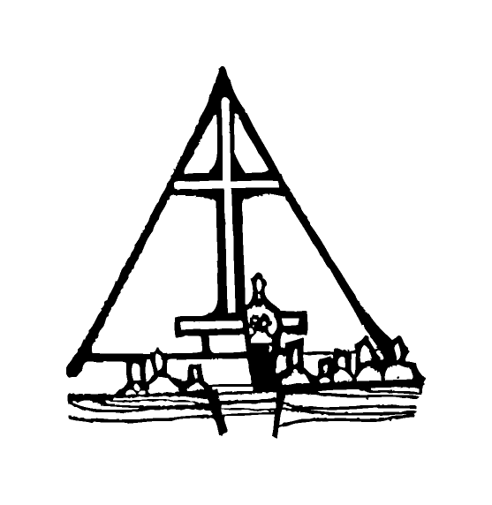 Maplewood, MN 55109

Dan Woolley, Organist 651-777-1329

[www.crosslutheranchurch.org](http://www.crosslutheranchurch.org) [cross@pro-ns.net](mailto:cross@pro-ns.net)

***Cross Lutheran Church***

**THE NINTH SUNDAY AFTER PENTECOST**

**July 26, 2015**

**Evangelical Lutheran Worship Book – Holy Communion Setting One**

We encourage worshippers to use the time in the sanctuary before the liturgy begins for silent meditation and prayer. The entire assembly will read the Gospel together; pew Bibles can be found in front of you, children’s Bibles and large print lessons are available from the ushers. Prayer for healing and anointing with oil is offered in the narthex during Holy Communion. Any worshipper wishing to receive these gifts may proceed there after receiving the host and the cup, and before returning to the pew.

***Bold Print*** *– indicates congregation responds as a whole*

***\**** *– indicates congregation should stand as able*

**PRELUDE**

**ANNOUNCEMENTS**

**\*CONFESSION AND FORGIVENESS**  p. 94 (red tab)

**\*OPENING HYMN** *Praise to the Lord, the Almighty* ELW # 858

**\*GREETING** p. 98

**\*KYRIE** p. 98

**\*HYMN OF PRAISE** *This is the Feast* p. 101

**\*PRAYER OF THE DAY**

**Gracious God, you have placed within the hearts of all your children a longing for your word and a hunger for your truth. Grant that we may know your Son to be the true bread of heaven and share this bread with all the world, through Jesus Christ, our Savior and Lord. Amen.**

**FIRST LESSON** II Kings 4:42-44 O.T. p. 336

**PSALM –** Psalm 145:10-18

*Cantor sings refrain (****R****). The congregation then repeats the refrain.*

*Congregation responds with the* ***bold verses.***

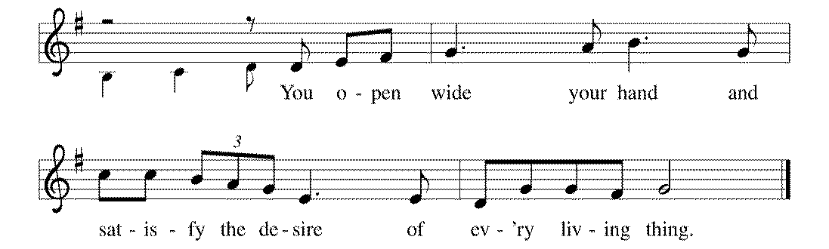



10All your works shall praise | you, O LORD,

and your faithful | ones shall bless you.

11**They shall tell of the glory | of your kingdom**

**and speak | of your power,**

12that all people may know | of your power

and the glorious splendor | of your kingdom.

13**Your kingdom is an everlasting kingdom; your dominion endures through- | out all ages.**

**You, LORD, are faithful in all your words, and loving in | all your works. R**

14The Lord upholds all | those who fall

and lifts up those who | are bowed down.

15**The eyes of all wait upon | you, O LORD,**

**and you give them their food | in due season.**

16You open | wide your hand

and satisfy the desire of every | living thing.

17**You are righteous in | all your ways**

**and loving in | all your works.**

18You are near to all who | call upon you,

to all who call up- | on you faithfully. **R**

**SECOND LESSON** Ephesians 3:14-21 N.T. p. 193

**\*GOSPEL ACCLAMATION** *Alleluia*p. 102

**\*GOSPEL RESPONSES** p. 103

**\*GOSPEL**

*(P) The Holy Gospel according to John 6:1-21 N.T. p. 97

**\*(C) Glory to you, O Lord.**

*(P) The Gospel of our Lord.

**\*(C) Praise to you, O Christ.**

**THE SERMON**

**\*HYMN OF THE DAY** *O Christ, What Can It Mean for Us* ELW # 431

**\*APOSTLES’ CREED** p. 127 (blue tab)

**\*PRAYERS OF THE PEOPLE**

**\*SHARING THE PEACE OF THE LORD**

**OFFERING**

**\*OFFERTORY RESPONSE** *Praise God, from Whom All Blessings Flow* ELW #885

**\*OFFERING PRAYER**  p. 107

**Blessed are you, O God, maker of all things. Through your goodness you have blessed us with these gifts: our selves, our time, and our possessions. Use us, and what we have gathered, in feeding the world with your love, through the one who gave himself for us, Jesus Christ, our Savior and Lord. Amen.**

**\*WORDS OF INSTITUTION**

**\*THE LORD’S PRAYER** p. 112

**DISTRIBUTION**

**To make the distribution of the Lord’s Supper as easy as possible, we ask that people who wish to commune and who use a wheelchair or walker come to the front first to receive the Sacrament.**

**LAMB OF GOD** p. 112

*In the Singing* ELW # 466

*Children of the Heavenly Father* ELW # 781

*When Peace like a River* ELW # 785

*Precious Lord, Take My Hand* ELW # 773

**\*POST COMMUNION PRAYER**

**\*BENEDICTION** p. 114

**\*CLOSING HYMN** *Hallelujah! We Sing Your Praises* ELW # 535

**\*DISMISSAL** p. 115

**POSTLUDE**

To Our Guests and Visitors Today: Every baptized believer who is of age is invited to receive the Lord’s Supper as we worship. The invitation is extended to each of us by the Lord himself, because he is the host of the meal. We also believe that he is the meal; that is that “in, with, and under” the bread and wine we do receive the body and blood of Christ, given and shed for us for the forgiveness of sins. Please follow the directions of the ushers if you wish to commune. Children under the age of ten are invited to receive a Word of blessing. ***Worshipers unable to commune at the front of the church…****Please register with an usher and a lay minister will bring the Supper to you in your pew*.

###### **THIS WEEK AT CROSS**

Sunday, July 26 9:00am Worship Service

3:30pm – 6:30pm Roca de Horeb

5:00pm 7th Day Adventists

6:30pm MIDWEST MYSTERY FINAL MEETING

Monday, July 27 6:30pm Parish Planning Council Meeting – Chapters 1 & 2

Tuesday, July 28 7:30pm – 8:30pm Roca de Horeb

Wednesday, July 29 10:30am Bible Study at Bel Rae Mounds View

Thursday, July 30 8:30am Garden Club

10:30am Bible Study at The Shores of Lake Phalen

3:00pmWorship Service at Bel Rae of Mounds View

6:30pm Worship Service at The Shores of Lake Phalen

7:00pm 7th Day Adventists Prayer Group

Friday, July 31 6:00pm – 9:30pm Roca de Horeb

Saturday, August 1 6:00am – 8:00am Roca de Horeb

9:30am – 12:00pm 7th Day Adventist

5:30pm – 9:00pm Roca de Horeb

Sunday, August 2 9:00am Worship Service

11:00am LEAVE on Midwest Mystery Summer Trip

3:30am Roca de Horeb

**Today you will find in the bulletin a table prayer**. We know that our Lord is the source of all blessings, and that it is most fitting for us to give thanks before we eat. Some people always pray the same prayer. Others prefer to pray different prayers – some don’t pray at all. A different prayer will be included each month to help us all in this daily devotion.

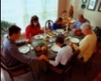Table Prayer

Our health is given by this food; our food, dear Lord, comes by your grace. Our thanks we offer in return at every meal, in every place. Amen.

Description: MCj03075560000[1]*Description: j0199727Stewardship Verse*

*Matthew 6:19-21*

*“Do not store up for yourselves treasures on earth, where moth and rust consume and where thieves break in and steal; but store up for yourselves treasures in heaven…For where your treasure is, there your heart will be also.”*

Be a good steward of the earth; if you aren’t taking your bulletin home,  
please drop it in the recycling bin in the narthex. Thank you!