Bob Preuss and Amy Oslund, Pastors 1945 Prosperity Road

Leah Bergman, Director of Music Maplewood, MN 55109

Dan Woolley, Organist 651-777-1329

[www.crosslutheranchurch.org](http://www.crosslutheranchurch.org) [cross@pro-ns.net](mailto:cross@pro-ns.net)

***Cross Lutheran Church***

**THE THIRTEENTH SUNDAY AFTER PENTECOST**

**August 23, 2015**

**Evangelical Lutheran Worship Book – Holy Communion Setting One**

We encourage worshippers to use the time in the sanctuary before the liturgy begins for silent meditation and prayer. The entire assembly will read the Gospel together; pew Bibles can be found in front of you, children’s Bibles and large print lessons are available from the ushers. Prayer for healing and anointing with oil is offered in the narthex during Holy Communion. Any worshipper wishing to receive these gifts may proceed there after receiving the host and the cup, and before returning to the pew.

***Bold Print*** *– indicates congregation responds as a whole*

***\**** *– indicates congregation should stand as able*

**PRELUDE**

**ANNOUNCEMENTS**

**\*CONFESSION AND FORGIVENESS**  p. 94 (red tab)

**\*OPENING HYMN** *We Praise You, O God* ELW # 870

**\*GREETING** p. 98

**\*KYRIE** p. 98

**\*HYMN OF PRAISE** *This is the Feast* p. 101

**\*PRAYER OF THE DAY**

**Holy God, your word feeds your people with life that is eternal. Direct our choices and preserve us in your truth, that, renouncing what is false and evil, we may live in you, through your Son, Jesus Christ, our Savior and Lord. Amen.**

**FIRST LESSON** Joshua 24:1-2a, 14-18 O.T. p. 215

**PSALM –** Psalm 34:15-22

*Cantor sings refrain (****R****). The congregation then repeats the refrain.*

*Congregation responds with the* ***bold verses.***

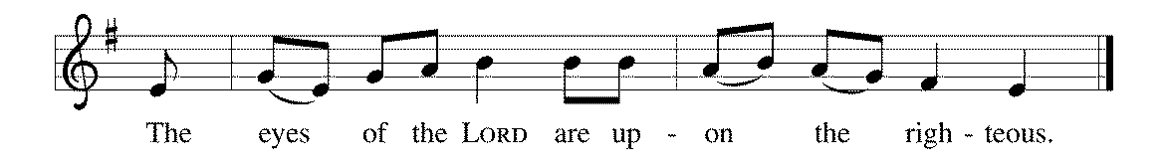

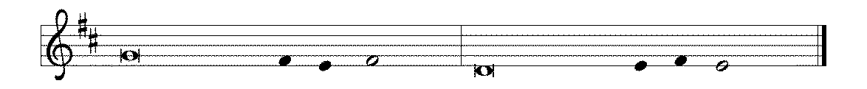

15The eyes of the LORD are up- | on the righteous,

and God's ears are open | to their cry.

16**The face of the LORD is against those | who do evil,**

**to erase the remembrance of them | from the earth.**

17The righteous cry, and | the LORD hears them

and delivers them from | all their troubles.

18**The LORD is near to the | brokenhearted**

**and saves those whose spir- | its are crushed. R**

19Many are the troubles | of the righteous,

but the LORD delivers them from | every one.

20**God will keep safe | all their bones;**

**not one of them | shall be broken.**

21Evil will bring death | to the wicked

and those who hate the righteous | will be punished.

22**O LORD, you redeem the life | of your servants,**

**and those who put their trust in you will | not be punished. R**

**SECOND LESSON** Ephesians 6:10-20 N.T. p. 195

**\*GOSPEL ACCLAMATION** *Alleluia*p. 102

**\*GOSPEL RESPONSES** p. 103

**\*GOSPEL**

*(P) The Holy Gospel according to John 6:56-69 N.T. p. 98

**\*(C) Glory to you, O Lord.**

*(P) The Gospel of our Lord.

**\*(C) Praise to you, O Christ.**

**THE SERMON**

**\*HYMN OF THE DAY** *Great Is Thy Faithfulness* ELW # 733

**\*APOSTLES’ CREED** p. 127 (blue tab)

**\*PRAYERS OF THE PEOPLE**

**\*SHARING THE PEACE OF THE LORD**

**OFFERING**

**\*OFFERTORY RESPONSE** *Praise God, from Whom All Blessings Flow* ELW #885

**\*OFFERING PRAYER**  p. 107

**Blessed are you, O God, maker of all things. Through your goodness you have blessed us with these gifts: our selves, our time, and our possessions. Use us, and what we have gathered, in feeding the world with your love, through the one who gave himself for us, Jesus Christ, our Savior and Lord. Amen.**

**\*WORDS OF INSTITUTION**

**\*THE LORD’S PRAYER** p. 112

**DISTRIBUTION**

**To make the distribution of the Lord’s Supper as easy as possible, we ask that people who wish to commune and who use a wheelchair or walker come to the front first to receive the Sacrament.**

**LAMB OF GOD** p. 112

*Joyful, Joyful We Adore Thee* ELW # 836

*Lord of All Hopefulness* ELW # 765

*Let Us Talents and Tongues Employ* ELW # 674

**\*POST COMMUNION PRAYER**

**\*BENEDICTION** p. 114

**\*CLOSING HYMN** *God, Whose Almighty Word* ELW # 673

**\*DISMISSAL** p. 115

**POSTLUDE**

To Our Guests and Visitors Today: Every baptized believer who is of age is invited to receive the Lord’s Supper as we worship. The invitation is extended to each of us by the Lord himself, because he is the host of the meal. We also believe that he is the meal; that is that “in, with, and under” the bread and wine we do receive the body and blood of Christ, given and shed for us for the forgiveness of sins. Please follow the directions of the ushers if you wish to commune. Children under the age of ten are invited to receive a Word of blessing. ***Worshipers unable to commune at the front of the church…****Please register with an usher and a lay minister will bring the Supper to you in your pew*.

###### **THIS WEEK AT CROSS**

Sunday, August 23 9:00am Worship Service

3:30pm – 6:30pm Roca de Horeb

4:00pm – 5:00pm Family Summer Choir Rehearsal

Tuesday, August 25 7:30pm – 8:30pm Roca de Horeb

Thursday, August 27 8:30am Garden Club

3:00pmWorship Service at Bel Rae of Mounds View

6:30pm Worship Service at The Shores of Lake Phalen

7:00pm 7th Day Adventists Prayer Group

Friday, August 28 6:00pm – 9:30pm Roca de Horeb

Saturday, August 29 6:00am – 8:00am Roca de Horeb

9:30am – 12:00pm 7th Day Adventist

5:30pm – 9:00pm Roca de Horeb

Sunday, August 30 9:00am Worship Service

3:30am Roca de Horeb

5:00pm 7th Day Adventist

**Today you will find in the bulletin a table prayer**. We know that our Lord is the source of all blessings, and that it is most fitting for us to give thanks before we eat. Some people always pray the same prayer. Others prefer to pray different prayers – some don’t pray at all. A different prayer will be included each month to help us all in this daily devotion.

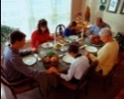Table Prayer

Heavenly Father, we’re thankful for this day with its many blessings and now for the nourishment of our bodies. Grant us also spiritual nourishment for our souls. We ask in Christ’s name. Amen.

Description: MCj03075560000[1]*Description: j0199727Stewardship Verse*

*Luke 12:48b*

*“From everyone to whom much has been given, much will be required; and from the one to whom much has been entrusted, even more will be demanded.”*

Be a good steward of the earth; if you aren’t taking your bulletin home,  
please drop it in the recycling bin in the narthex. Thank you!