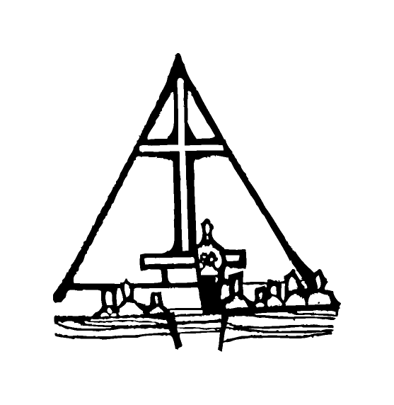Bob Preuss and Amy Oslund, Pastors 1945 Prosperity Road

Leah Bergman, Director of Music Maplewood, MN 55109

www.crosslutheranchurch.org 651-777-1329

[cross@pro-ns.net](mailto:cross@pro-ns.net)

***Cross Lutheran Church***

**THE SIXTEENTH SUNDAY AFTER PENTECOST**

**September 13, 2015**

**ALTERNATIVE SERVICE**

**Our Mission Statement**

**Cross Lutheran Church is a community of believers united by our baptism into Christ Jesus. We are committed to proclaiming and teaching the Good News of God’s love and sharing His love by serving our neighbors in all we do. We invite all to be a part of our fellowship as we grow in grace and follow Christ.**

***Bold Print*** *– indicates congregation responds as a whole*

***\**** *– indicates congregation should stand as able*

**GATHERING SONGS**

**ANNOUNCEMENTS**

**\*CONFESSION AND FORGIVENESS** *You Are Mine*p. 1

**\*OPENING HYMN** *Gather Us In* RB # 27

**CALL TO WORSHIP** *O God in Heaven*p. 2

**\*GOD’S CALL TO US** *Go, Make Disciples* p. 3

**\*PRAYER OF THE DAY**

**O God, through suffering and rejection you bring forth our salvation, and by the glory of the cross you transform our lives. Grant that for the sake of the gospel we may turn from the lure of evil, take up our cross, and follow your Son, Jesus Christ, our Savior and Lord. Amen.**

**FIRST LESSON** Joshua 3:7 – 4:6, 22-24 O.T. p. 195

**PSALM 116:1-9**

*Cantor sings refrain (****R****). The congregation then repeats the refrain.*

*Congregation responds with the* ***bold verses.***



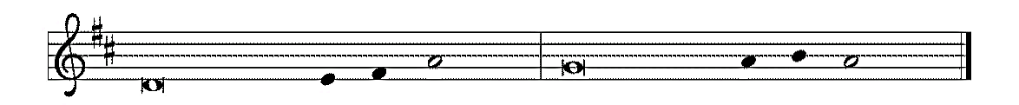

1I love the LORD, who has | heard my voice,

and listened to my | supplication,

2**for the LORD has given | ear to me**

**whenev- | er I called.**

3The cords of death entangled me; the anguish of the grave | came upon me;

I came to | grief and sorrow.

4**Then I called upon the name | of the LORD:**

**"O LORD, I pray you, | save my life." R**

5Gracious is the | LORD and righteous;

our God is full | of compassion.

6**The LORD watches o- | ver the innocent;**

**I was brought low, | and God saved me.**

7Turn again to your rest, | O my soul.

for the LORD has dealt | well with you.

8**For you have rescued my | life from death,**

**my eyes from tears, and my | feet from stumbling;**

9I will walk in the presence | of the LORD

in the land | of the living. **R**

**SECOND LESSON** James 3:1-12 N.T. p. 230

**\*GOSPEL ACCLAMATION** *The God of Heaven Thunders* p. 3

**\*GOSPEL** Mark 8:27-38 N.T. p. 43

**THE SERMON**

**\*HYMN OF THE DAY** *Let Us Talents and Tongues Employ*RB # 90

**\*APOSTLES’ CREED** *I Believe in God the Father*p. 4

**\*PRAYERS OF THE PEOPLE WITH SUNG RESPONSE** p. 5

**\*SHARING THE PEACE OF THE LORD**

**OFFERING**

**\*OFFERTORY RESPONSE** *Give Thanks with a Grateful Heart* p. 5

**\*WORDS OF INSTITUTION** p. 6

**\*THE LORD’S PRAYER**

**DISTRIBUTION**

**To make the distribution of the Lord’s Supper as easy as possible, we ask that people who wish to commune and who use a wheelchair or walker come to the front first to receive the Sacrament.**

**ANNOINTING**

**Prayer for healing and anointing with oil is offered in the narthex during Holy Communion. Any worshipper wishing to receive these gifts may proceed there after receiving the host and the cup, and before returning to the pew.**

**LAMB OF GOD** *Now Behold the Lamb of God* p. 6

*As the Grains of Wheat* RB # 37

*You Are Holy* RB # 30

*Listen, God Is Calling* RB # 92

*What Can Wash Away My Sin?* RB # 44

*He Came Down* RB # 2

**\*POST COMMUNION PRAYER** p. 6

**\*BENEDICTION** p. 6

**\*CLOSING HYMN***Hands, Hearts, and Voices*RB # 11

\***DISMISSAL** p. 7

**\*POSTLUDE** *You Are Mine* p. 7

The First Commandment is: **I am the Lord your God. You shall have no other gods before me. What does this mean? We are to fear, love, and trust God above anything else.**

To Our Guests and Visitors Today: Every baptized believer who is of age is invited to receive the Lord’s Supper as we worship. The invitation is extended to each of us by the Lord himself, because he is the host of the meal. We also believe that he is the meal; that is that “in, with, and under” the bread and wine we do receive the body and blood of Christ, given and shed for us for the forgiveness of sins. Please follow the directions of the ushers if you wish to commune. Children under the age of ten are invited to receive a Word of blessing. ***Worshipers unable to commune at the front of the church****…Please register with an usher and a lay minister will bring the Supper to you in your pew*.

###### **THIS WEEK AT CROSS**

Sunday, September 13 **9:30am Worship Service**

10:30am Jet Fuel Store

10:45am Sunday School Kickoff

11:00am Adult Education – Jill Miklausich – John Glenn Principal

12:00pm Board of Church Properties Meeting

3:30am Roca de Horeb

5:00pm 7th Day Adventist

Monday, September 14 6:30pm Board of Education Meeting

7:00pm Board of Lay Ministry Meeting

Tuesday, September 15 7:30pm – 8:30pm Roca de Horeb

Wednesday, September 16 6:30pm Confirmation Class

7:00pm Hands, Hearts and Voices Choir Rehearsal

Thursday, September 17 8:30am Garden Club

3:00pmWorship Service at Bel Rae of Mounds View

6:30pm Worship Service at The Shores of Lake Phalen

7:00pm 7th Day Adventists Prayer Group

Friday, September 18 6:00pm – 9:30pm Roca de Horeb

Saturday, September 19 6:00am – 8:00am Roca de Horeb

7:00am – 4:00pm Roca de Horeb Parking Lot Sale

9:30am – 12:00pm 7th Day Adventist

5:30pm – 9:00pm Roca de Horeb

7:00pm – 9:00pm S.N.A.C. at the Gudknecht’s House

Sunday, September 16 7:00am – 4:00pm Roca de Horeb Parking Lot Sale

9:00am Worship Service

10:45am Worship Service at The Homestead of Maplewood

3:30am Roca de Horeb

**Today you will find in the bulletin a table prayer**. We know that our Lord is the source of all blessings, and that it is most fitting for us to give thanks before we eat. Some people always pray the same prayer. Others prefer to pray different prayers – some don’t pray at all. A different prayer will be included each month to help us all in this daily devotion.

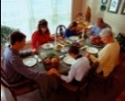Table Prayer

The table now with food is spread. Oh God, Who gives us daily bread, bless these Thy gifts, unto us so strength of body they bestow.

Description: MCj03075560000[1]

*Description: j0199727Stewardship Verse*

*Matthew 5:15-16*

*“No one after lighting a lam puts it under the bushel basket, but on the lamp stand, and it gives light to all in the house. In the same way, let your light shine before others, so that they may see your good works and give glory to your Father in heaven.”*